# **Library Management**

# **Sprint 1 and Sprint 2**

# ***Submitted by***

# **BL.EN.U4CSE17138 V Akhil**

# **BL.EN.U4CSE17510 K Kamal**

# **BL.EN.U4CSE17523 T V Premchand**

# **BL.EN.U4CSE17524 Y V Sravan Kumar Reddy**

# **BL.EN.U4CSE17541 Ajith Pai**

# **BL.EN.U4CSE17553 E Srekar**

# ***In partial fulfilment of the requirements for the completion of Agile Use cases for***

# **Project-based Course**

# **15CSE313 SOFTWARE ENGINEERING**



# **AMRITA SCHOOL OF ENGINEERING, BENGALURU**

# **AMRITA VISHWA VIDYAPEETHAM**

# **BENGALURU 560035**

# **JUNE-2020**

# **Library Management Sprint Report**

## **Sprint 1 Ending 28/02/2020**

## **Sprint 2 Ending 10/06/2020**

## **Context**

First Day of Sprint 1: 21/02/2020

Last Day of Sprint 1: 29/02/2020

First Day of Sprint 2: 8/06/2020

Last Day of Sprint 2: 10/06/2020

Working Days in Sprint 1: 16

Working Days in Sprint 2: 30

### **Team Members**

The following cross-functional team members participated in the sprint. Also listed are the days they were expected to work and the number of days they did work.

|  |  |  |  |
| --- | --- | --- | --- |
| **Name** | **Role in the Sprint** | **Planned Days** | **Worked Days** |
| Ajith Pai | Scrum Master | **46** | **46** |
| Kamal Kandula | Developer1 | **15** | **10** |
| Y V Sravan Kumar | Developer2 | **20** | **30** |
| Eskala Srekar | Developer3 | **40** | **40** |
| Premchand & Akhil | Testers | **6** | **6** |

**Sprint 1 and Sprint 2 Sprint 1 and Sprint 2**

**Internal Assessor Product Owner**

## **1.** **User Stories**

|  |  |  |  |
| --- | --- | --- | --- |
| User Story ID | As a <type of user> | I want to <perform some task> | so that I can <achieve some goal> |
| 1 | Scrum Master | I want to Assign work to members, Track and report the Team’s progress and manage the project according to Customers needs | So that I can Ensure the project stays on track and Team does the work according to the timeline and desired outcome is derived. |
| 2 | Developer 1 | I want to develop a few modules in the front end with attractive UI and graphics with images. | So that I can ensure the view and the appearance of the project according to customer needs and is attractive in sight. |
| 3 | Developer 2 | I want to develop a few modules in the front end and helps in backend connection for data sent to database | So that I can ensure the appearance of the project is user friendly, data is transferred to a database in a secured channel. |
| 4 | Developer 3 | I want to develop the database and connect modules with the data. | So that I can ensure the back end is well connected with the front end and data is stored in the database efficiently and securely. |
| 5 | Tester 1 | I want to test the project with the use of different cases | So that I can find the errors, loopholes in the project and intimate the developer to rectify it and prevent from customer facing issues. |
| 6 | Tester 2 | I want to test the project with the use of different cases | So that I can find the errors, loopholes in the project and intimate the developer to rectify it and prevent from customer facing issues. |

## 

## 

## **2.** **Product Backlogs**

|  |  |  |  |  |  |  |  |  |  |  |
| --- | --- | --- | --- | --- | --- | --- | --- | --- | --- | --- |
| **Ref** | **Description** | **Type** | **Group** | **Relative Value** | **Initial Estimate** | **Adjust Factor** | **Estimate** | **Release** | **Sprint** | **Status** |
| 1 | New customer is registered into the application with registration form | Feature | Registration | 10 | 3 | 0 | 3 | 1.0.0 | 1 | Done |
| 2 | As a secure login with username and password feature must be applied for account access | Feature | Authentication | 10 | 1 | 0 | 1 | 1.1.0 | 1 | Done |
| 3 | Header functions of Booking management, profile management and wallet management | Feature | User-Interface | 10 | 2 | 1 | 4 | 1.2.1 | 1 | Done |
| 4 | Display details by retrieving the information from database for showing to the user | New feature | Customer Management | 10 | 3 | 0 | 3 | 2.1.0 | 1 | Done |
| 5 | Uploading Image for profile Pic in registration page | New feature | Registration | 8 | 2 | 0 | 2 | 2.2.0 | 1 | Done |
| 6 | Wallet management with adding money, saving card feature | New feature | Payment | 10 | 3 | 0 | 3 | 2.3.0 | 1 | Done |
| 7 | UI glitches fixed, Login time reduced | Enhancement | Customer Management | 5 | 3 | 0 | 3 | 2.3.1 | 1 | Done |
| 8 | KYC document Upload | New feature | KYC verification | 10 | 3 | 0 | 3 | 3.1.0 | 1 | Done |
| 9 | Booking feature with history and displaying all details of book in the new booking page | New feature | Booking window | 10 | 5 | 0 | 5 | 3.2.0 | 1 | Done |
| 10 | Booking feature with history and displaying all details of book in the new booking page | Enhancement | Booking window | 10 | 3 | 0 | 3 | 3.2.1 | 2 | Done |
| 11 | Enabling payment of bills and cart checkout after adding the books in cart | New feature | Booking window | 10 | 5 | 1 | 10 | 3.3.0 | 2 | Done |
| 12 | KYC approval and status display. | New feature | KYC verification | 10 | 3 | 0 | 3 | 4.1.0 | 2 | Done |
| 13 | Admin Management role for managing all features of adding, deleting and updating book features with KYC manual checking feature. | New feature | Admin Management | 10 | 5 | 1 | 10 | 5.1.0 | 2 | Done |
| 14 | Database enhancement and reload time fix | Enhancement | User-Interface | 5 | 2 | 0 | 2 | 5.1.1 | 2 | Done |
| 15 | Constraint errors fixed for registration, login , update forms | defect | Customer Management | 10 | 2 | 0 | 2 | 5.2.0 | 2 | Done |
| 16 | User-interface modified and made more interactive | Enhancement | User-Interface | 5 | 1 | 0 | 1 | 5.3.1 | 2 | Done |
| 17 | Testing errors fixes and enchanted features | Enhancement | Security | 5 | 2 | 1 | 4 | 5.3.2 | 2 | Done |
| 18 | Final debugging, testing and glitches fixes | Enhancement | whole Application | 5 | 1 | 0 | 1 | 5.3.3 | 2 | Done |
| 19 | Project delivery | N/A | whole Application | 10 | N/A | N/A | N/A | 5.4.0 | 3 | Commit |

## **3.** **Iteration Planning**

You have to write and insert the Iteration plan for each module of Sprints based on the template provided to you.

Iteration Planning done with the Product Owner

Select from the following activities. Note why you have or have not chosen an activity:

Ø Introduction: Project requirement shared. Choose the Activity to make a clear idea and requirement of the customer.

Ø Vision and Roadmap: SRS document shared to the team . Choose the activity to provide a hawkeye vision of the project documentation and a roadmap of the features involved will help the team work consistently.

Ø Number of user stories fit : User Story created. Choose the activity essentially to know what are the user stories that can be performed by each team member.

Ø Current Status: Product Backlog created. Choose the activity so that the team understands progress in real time.

Ø Iteration Theme / Name(Not Chosen): It is not of utmost necessity to have nomenclature for an iteration. In our project, iterations are a mix of different functionality. It will be better to name each functionality than a whole iteration:

Ø Prior Data (Not Chosen): Our project does not need any type of prior data.

Ø Dates: It's important to follow the dates to meet the deadlines and deliver the product in time.

Ø Capacity : It is important for the Scrum Master to have an estimate of each member’s capacity of work in order to be able to provide work.

Ø Issues / Logistics : Important to understand the areas where the team is getting stuck.

Ø DOD: Necessary for the team to understand when a particular functionality is to be declared as Done.

Ø Backlog Extract: Must be updated with every module that is completed.

Ø Tasking: Important for the team to divide user stories into tasks in order to finish each user story in an efficient manner.

Ø Issues and Risks: Probable risks have to be calculated and issues (such as overshooting of a deadline due to lack of availability of certain team members).

Ø Dependencies and Assumptions: We need to take into consideration several aspects in the Library management Application.

Ø “Commitment”: It is important that every member commits time for their part of work.

Ø Actions: Every team member must perform their work in accordance to the plan of action set up by the team.

Ø Retrospect: Meetings are fuelled by feedback from previous meetings.

Are there any extra activities specific to your team or process that you need?

Ø Agility : The ability for team members to be able to interchange their roles in each sprint in order to effectively learn new work. Also, to adapt to the changing needs of the customer.

Provide a range estimate for how long each selected activity will take for your team.

Total : 25.6 story points.

## 

## 

## **4.** **Daily Scrum Report**

|  |  |  |  |  |  |  |  |  |  |  |
| --- | --- | --- | --- | --- | --- | --- | --- | --- | --- | --- |
| Unique ID | User Stories | Particulars (Today's work- Date to be mentioned) | Assignee | Reporter (Scrum Master) | Present / Absent | Status | Resolution | Created | Due | Fix Version/s |
| 1 | Create Git Repository | adding all members and checking the clone for all the members | Eskala Srekar | Ajith Pai | Present | completed | resolved | 16-01-2020 | 17-01-2020 | N/A |
| 2 | Module workflow | making the workflow plan for the entire project | Ajith Pai | Ajith Pai | Present | completed | resolved | 17-01-2020 | 17-01-2020 | N/A |
| 3 | Database Design | Design and correction of the database to be used for the project | Ajith Pai | Ajith Pai | Present | completed | resolved | 18-01-2020 | 19-01-2020 | N/A |
| 4 | Idea Finalising | Finalising the whole project implementation. | Eskala Srekar | Ajith Pai | Present | completed | resolved | 18-01-2020 | 19-01-2020 | N/A |
| 5 | Firebase account | making the firebase hosting account | Ajith Pai | Ajith Pai | Present | completed | resolved | 20-01-2020 | 21-01-2020 | N/A |
| 6 | Create online url | Making the url id and deploy hello world | Kamal Kandula | Ajith Pai | Present | completed | resolved | 22-01-2020 | 23-01-2020 | N/A |
| 7 | SRS document Completion | to make the SRS document for the project | Kamal Kandula | Ajith Pai | Present | completed | resolved | 23-01-2020 | 28-01-2020 | 1.0.0 |
| 8 | SRS document Correction | All the errors, unrelated details and mistakes are corrected | Ajith Pai | Ajith Pai | Present | completed | resolved | 28-01-2020 | 30-01-2020 | 1.1.0 |
| 9 | Login management with OTP | The login management is made with Firebase | Kamal Kandula | Ajith Pai | Present | completed | resolved | 30-01-2020 | 03-02-2020 | 1.2.1 |
| 10 | login test | testing the login | Prem Chand | Ajith Pai | Present | completed | resolved | 03-02-2020 | 05-02-2020 | 1.2.1 |
| 11 | login test | testing the login | Akhil | Ajith Pai | Present | completed | resolved | 03-02-2020 | 05-02-2020 | 1.2.1 |
| 12 | Login Edits made | Changed the Login codes for more optimised results | Ajith Pai | Ajith Pai | Present | completed | resolved | 05-02-2020 | 08-02-2020 | 2.1.0 |
| 13 | Agile Doc. | Agile Document filled | Kamal Kandula | Ajith Pai | Present | completed | resolved | 03-02-2020 | 08-02-2020 | N/A |
| 14 | Agile Doc. Edit | Agile Document is edited for making it more precise | Ajith Pai | Ajith Pai | Present | completed | resolved | 08-02-2020 | 09-02-2020 | N/A |
| 15 | Front End Work | the project frontend development is started | Sravan | Ajith Pai | Present | completed | resolved | 17-02-2020 | 25-02-2020 | 2.2.0 |
| 16 | Backend Work | the connections for frontend with Backend to be made | Eskala Srekar | Ajith Pai | Present | completed | resolved | 20-02-2020 | 25-02-2020 | 2.1 |
| 17 | Image Upload | The Image put by user must be stored to database | Eskala Srekar | Ajith Pai | Present | completed | resolved | 03-03-2020 | 08-03-2020 | N/A |
| 18 | Lockdown Phase | Due to the Pandemic there was a few days gap to communicate. | whole team | Ajith Pai | Absent | N/A | N/A | 14-03-2020 | 07-04-2020 | N/A |
| 19 | KYC Upload | The KYC Image put by user must be stored to database | Eskala Srekar | Ajith Pai | Present | completed | resolved | 07-04-2020 | 14-04-2020 | 2.3.0 |
| 20 | UI glitches fixes | There were few changes in UI | Sravan | Ajith Pai | Present | completed | resolved | 10-04-2020 | 14-04-2020 | 2.3.1 |
| 21 | Admin Profile | Creating Admin role and creating dashboard | Sravan | Ajith Pai | Present | completed | resolved | 15-04-2020 | 20-04-2020 | 3.1.0 |
| 22 | Admin Profile | all Admin functionality work | Eskala Srekar | Ajith Pai | Present | completed | resolved | 21-04-2020 | 25-04-2020 | 3.2.0 |
| 23 | Admin Profile | all Admin functionality work UI | Sravan | Ajith Pai | Present | completed | resolved | 22-04-2020 | 24-04-2020 | 3.2.1 |
| 24 | Wallet | In app Wallet making UI | Sravan | Ajith Pai | Present | completed | resolved | 25-04-2020 | 30-04-2020 | 3.3.0 |
| 25 | Wallet | In app Wallet Backend | Eskala Srekar | Ajith Pai | Present | completed | resolved | 01-05-2020 | 07-05-2020 | 4.1.0 |
| 26 | Add Cart/Checkout | User profile working completion UI | Sravan | Ajith Pai | Present | completed | resolved | 08-05-2020 | 15-05-2020 | 5.1.0 |
| 27 | logout/ Update Profile | Final working of the module | Eskala Srekar | Ajith Pai | Present | completed | resolved | 09-05-2020 | 16-05-2020 | 5.1.1 |
| 28 | logout/ Update Profile | Final working of the module | Kamal Kandula | Ajith Pai | Present | completed | resolved | 10-05-2020 | 17-05-2020 | 5.2.0 |
| 29 | Testing | Complete Application testing | Premchand/Akhil | Ajith Pai | Present | completed | resolved | 17-05-2020 | 25-05-2020 | 5.3.1 |
| 30 | Test error Fix | Fixing all the errors discovered | Kamal Kandula | Ajith Pai | Present | completed | resolved | 25-05-2020 | 26-05-2020 | 5.3.2 |
| 31 | Final Testing | Final debugging, testing and glitches fixes | Premchand/Akhil | Ajith Pai | Present | completed | resolved | 26-05-2020 | 28-05-2020 | 5.3.3 |
| 32 | Project delivery | Final Deployment of the project | Ajith Pai | Ajith Pai | Present | completed | resolved | 29-05-2020 | 10-06-2020 | 5.4.0 |

## 

## 

## 

## **5.** **Test Cases for Sprint 1**

|  |  |  |  |  |  |  |  |
| --- | --- | --- | --- | --- | --- | --- | --- |
| **Project Name: Library Management** | | | | | | | |
| **Test Case Template** | | | | | | | |
| **Test Case ID: Fun_1** | | | | **Test Designed by: Ajith Pai** | | | |
| **Test Priority (Low/Medium/High): Med** | | | | **Test Designed date: 03/02/2020** | | | |
| **Module Name:login and registration screen** | | | | **Test Executed by: Akhil** | | | |
| **Test Title: Verify login with valid username and password and registration** | | | | **Test Execution date: 05/02/2020** | | | |
| **Description: Verify login with valid username and password and registration.** | | | |  | | | |
| **Pre-conditions: User has valid username and password** | | | | | | | |
| **Dependencies:** | | | | | | | |
| **Step** | **Test Steps** | **Test Data** | **Expected Result** | | **Actual Result** | **Status (Pass/Fail)** | **Notes** |
|  | Navigate to login page | User= example@gmail.com | User should be able to login | | User is navigated to | Pass |
| 1 |  |
| 2 | Provide valid username | Password: 1234 | User should not be able to login | | dashboard with unsuccessful | Pass |  |
| 3 | Provide valid password |  | Login | | Login | Pass |  |
| 4 | Click on Login button |  | Notification | | Notification | Pass |  |

|  |  |  |  |  |  |  |  |
| --- | --- | --- | --- | --- | --- | --- | --- |
| **Project Name: Library Management** | | | | | | | |
| **Test Case Template** | | | | | | | |
| **Test Case ID: Fun_2** | | | | **Test Designed by: Ajith Pai** | | | |
| **Test Priority (Low/Medium/High): Med** | | | | **Test Designed date: 03/02/2020** | | | |
| **Module Name:login and registration screen** | | | | **Test Executed by: Premchand** | | | |
| **Test Title: Verify login with valid username and password and registration** | | | | **Test Execution date: 05/02/2020** | | | |
| **Description: Verify login with valid username and password and registration.(admin module)** | | | |  | | | |
| **Pre-conditions: User has valid username and password** | | | | | | | |
| **Dependencies:** | | | | | | | |
| **Step** | **Test Steps** | **Test Data** | **Expected Result** | | **Actual Result** | **Status (Pass/Fail)** | **Notes** |
|  | Navigate to login page | User= Prem@gmail.com | User should be able to login | | User is navigated to | Pass |
| 1 |  |
| 2 | Provide valid username | Password: Qwerty@123 | User should be able to login | | dashboard with successful | Pass |  |
| 3 | Provide valid password |  | Login | | Login | Pass |  |
| 4 | Click on Login button |  | Notification | | Notification | Pass |  |

## 

|  |  |  |  |  |  |  |  |
| --- | --- | --- | --- | --- | --- | --- | --- |
| **Project Name: Library Management** | | | | | | | |
| **Test Case Template** | | | | | | | |
| **Test Case ID: Fun_3** | | | | **Test Designed by: Ajith Pai** | | | |
| **Test Priority (Low/Medium/High): High** | | | | **Test Designed date: 15/04/2020** | | | |
| **Module Name:Image Upload** | | | | **Test Executed by: Akhil** | | | |
| **Test Title: KYC Image** | | | | **Test Execution date: 15/04/2020** | | | |
| **Description: Verify Upload** | | | |  | | | |
|  | | | |  | | | |
| **Pre-conditions: User has valid username and password** | | | | | | | |
| **Dependencies:** | | | | | | | |
| **Step** | **Test Steps** | **Test Data** | **Expected Result** | | **Actual Result** | **Status (Pass/Fail)** | **Notes** |
|  | Upload Image | Pdf file | Should not be accepted | | Not accepted | Pass |
| 1 |  |
| 2 | Provide valid image | jpg | Image should upload | | successful | Pass | Takes long time |

## 

|  |  |  |  |  |  |  |  |
| --- | --- | --- | --- | --- | --- | --- | --- |
| **Project Name: Library Management** | | | | | | | |
| **Test Case Template** | | | | | | | |
| **Test Case ID: Fun_4** | | | | **Test Designed by: Ajith Pai** | | | |
| **Test Priority (Low/Medium/High): High** | | | | **Test Designed date: 17/04/2020** | | | |
| **Module Name:Image Upload** | | | | **Test Executed by: Premchand** | | | |
| **Test Title: KYC Image(Admin Module)** | | | | **Test Execution date: 20/04/2020** | | | |
| **Description: Verify Upload** | | | |  | | | |
|  | | | |  | | | |
| **Pre-conditions: User has valid username and password** | | | | | | | |
| **Dependencies:** | | | | | | | |
| **Step** | **Test Steps** | **Test Data** | **Expected Result** | | **Actual Result** | **Status (Pass/Fail)** | **Notes** |
|  | Upload Image | Pdf file | Should not be accepted | | Not accepted | Pass |
| 1 |  |
| 2 | Provide valid image | jpg | Image should upload | | successful | Pass | Time issue fixed |

## 

## **Sprint 2**

|  |  |  |  |  |  |  |  |
| --- | --- | --- | --- | --- | --- | --- | --- |
| **Project Name: Library Management** | | | | | | | |
| **Test Case Template** | | | | | | | |
| **Test Case ID: Fun_5** | | | | **Test Designed by: Ajith Pai** | | | |
| **Test Priority (Low/Medium/High): High** | | | | **Test Designed date: 25/04/2020** | | | |
| **Module Name: Add Cart/Checkout** | | | | **Test Executed by: Akhil** | | | |
| **Test Title: Cart working test** | | | | **Test Execution date: 25/04/2020** | | | |
| **Description: Verify Cart working** | | | |  | | | |
| **Pre-conditions: User has valid username and password** | | | | | | | |
| **Dependencies:** | | | | | | | |
| **Step** | **Test Steps** | **Test Data** | **Expected Result** | | **Actual Result** | **Status (Pass/Fail)** | **Notes** |
|  | Add to cart |  | Should be accepted | | accepted | Pass |
| 1 |  |
| 2 | Checkout |  | Should be reflected in bookings | | successful | Pass |  |

## 

|  |  |  |  |  |  |  |  |
| --- | --- | --- | --- | --- | --- | --- | --- |
| **Project Name: Library Management** | | | | | | | |
| **Test Case Template** | | | | | | | |
| **Test Case ID: Fun_6** | | | | **Test Designed by: Ajith Pai** | | | |
| **Test Priority (Low/Medium/High): High** | | | | **Test Designed date: 25/04/2020** | | | |
| **Module Name:Wallet** | | | | **Test Executed by: Premchand** | | | |
| **Test Title: Wallet working test** | | | | **Test Execution date: 25/04/2020** | | | |
| **Description: complete Module work** | | | |  | | | |
| **Pre-conditions: User has valid username and password** | | | | | | | |
| **Dependencies:** | | | | | | | |
| **Step** | **Test Steps** | **Test Data** | **Expected Result** | | **Actual Result** | **Status (Pass/Fail)** | **Notes** |
|  | Add Money | Card details | Should be accepted | | accepted | Pass |
| 1 |  |
| 2 | Save card | Card details | Details should upload | | successful | Pass |  |

## 

|  |  |  |  |  |  |  |  |
| --- | --- | --- | --- | --- | --- | --- | --- |
| **Project Name: Library Management** | | | | | | | |
| **Test Case Template** | | | | | | | |
| **Test Case ID: Fun_7** | | | | **Test Designed by: Ajith Pai** | | | |
| **Test Priority (Low/Medium/High): High** | | | | **Test Designed date: 17/05/2020** | | | |
| **Module Name:Update Details** | | | | **Test Executed by: Premchand** | | | |
| **Test Title: Details of the users are updated** | | | | **Test Execution date: 20/05/2020** | | | |
| **Description: Verify Updates** | | | |  | | | |
| **Pre-conditions: User has valid username and password** | | | | | | | |
| **Dependencies:** | | | | | | | |
| **Step** | **Test Steps** | **Test Data** | **Expected Result** | | **Actual Result** | **Status (Pass/Fail)** | **Notes** |
|  | Update details | Name= Prem | Should be accepted | | accepted | Pass |
| 1 |  |
| 2 | Preferences change | Pref= arts | Should be accepted | | successful | Pass |  |

## 

|  |  |  |  |  |  |  |  |
| --- | --- | --- | --- | --- | --- | --- | --- |
| **Project Name: Library Management** | | | | | | | |
| **Test Case Template** | | | | | | | |
| **Test Case ID: Fun_4** | | | | **Test Designed by: Ajith Pai** | | | |
| **Test Priority (Low/Medium/High): High** | | | | **Test Designed date: 20/05/2020** | | | |
| **Module Name:Whole Application** | | | | **Test Executed by: Premchand/Akhil** | | | |
| **Test Title: Whole application** | | | | **Test Execution date: 21/04/2020** | | | |
| **Description: Verify all modules working** | | | |  | | | |
|  | | | |  | | | |
| **Pre-conditions: User has valid username and password** | | | | | | | |
| **Dependencies:** | | | | | | | |
| **Step** | **Test Steps** | **Test Data** | **Expected Result** | | **Actual Result** | **Status (Pass/Fail)** | **Notes** |
|  | All modules test | All type of credentials | Should satisfy the constraints | | accepted | Pass |
| 1 |  |
| 2 | UI/UX |  | Should work perfectly | | successful | Pass | Few time glitches found |

**6.** **Contents and Assessment**

Points Planned: 20

Points Earned: 19

|  |  |  |
| --- | --- | --- |
| **Story** | **Points** | **Result** |
| Registration | **3** | **Finished** |
| Login | **1** | **Finished** |
| UI/UX | **5** | **Finished** |
| Add Book | **1** | **Finished** |
| Delete Book | **1** | **Finished** |
| Update Book | **1** | **Finished** |
| KYC update | **2** | **Finished** |
| Add to Cart/ Checkout | **2** | **Finished** |
| Testing | **3** | **Finished** |
| Daily report/ Product backlog/ Final Report | **1** | **Not Finished** |

### 

### **7.** **Sprint 1 Implementation**

Home page:



Signup page:

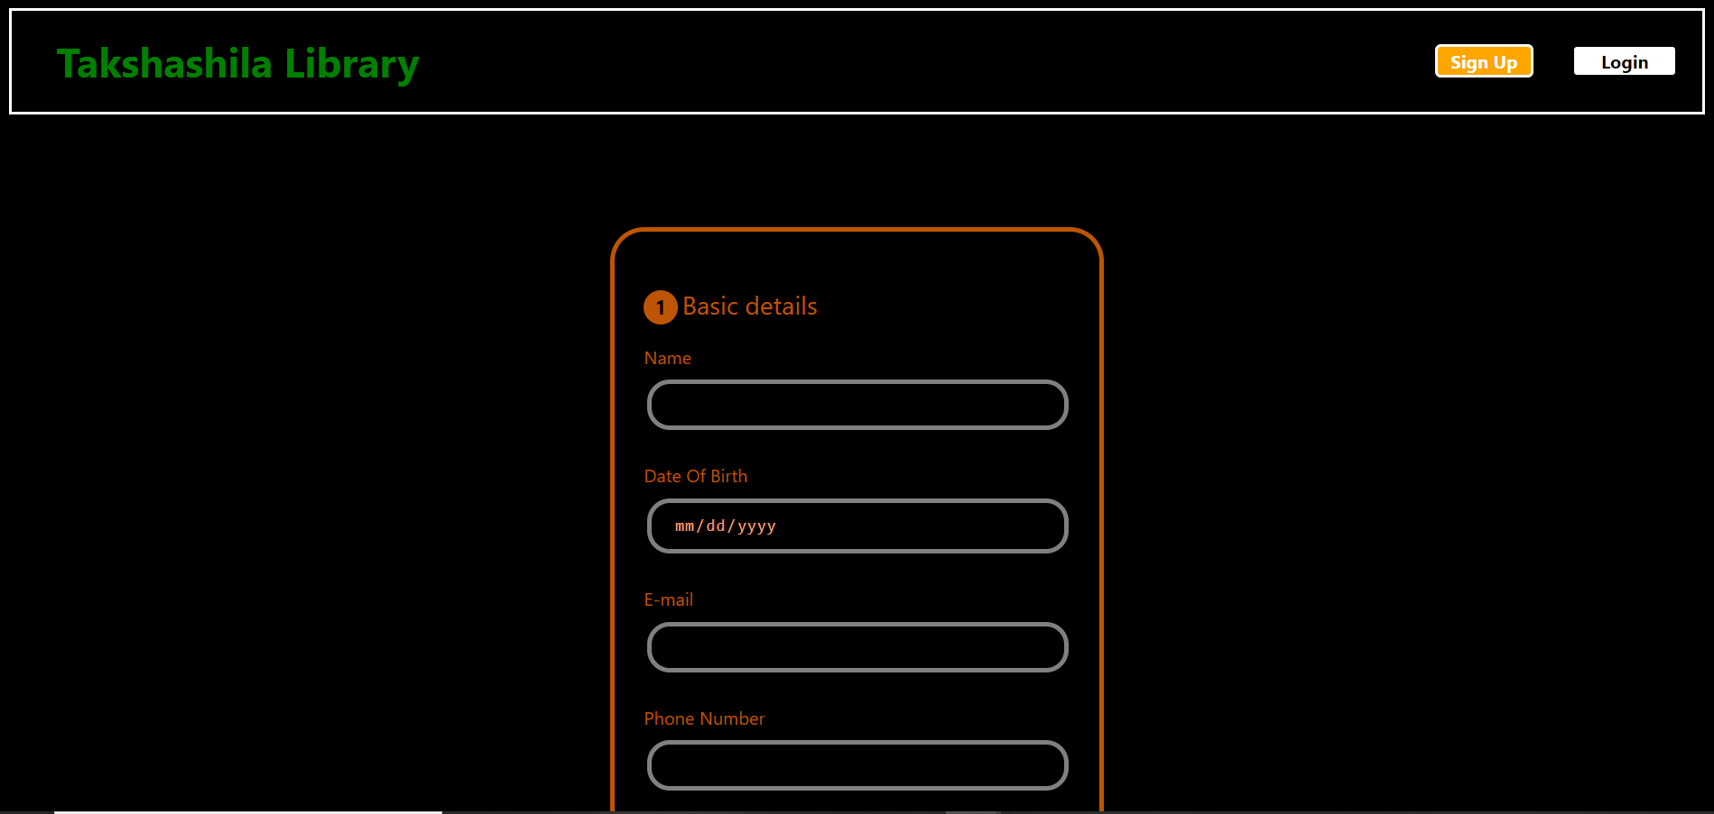

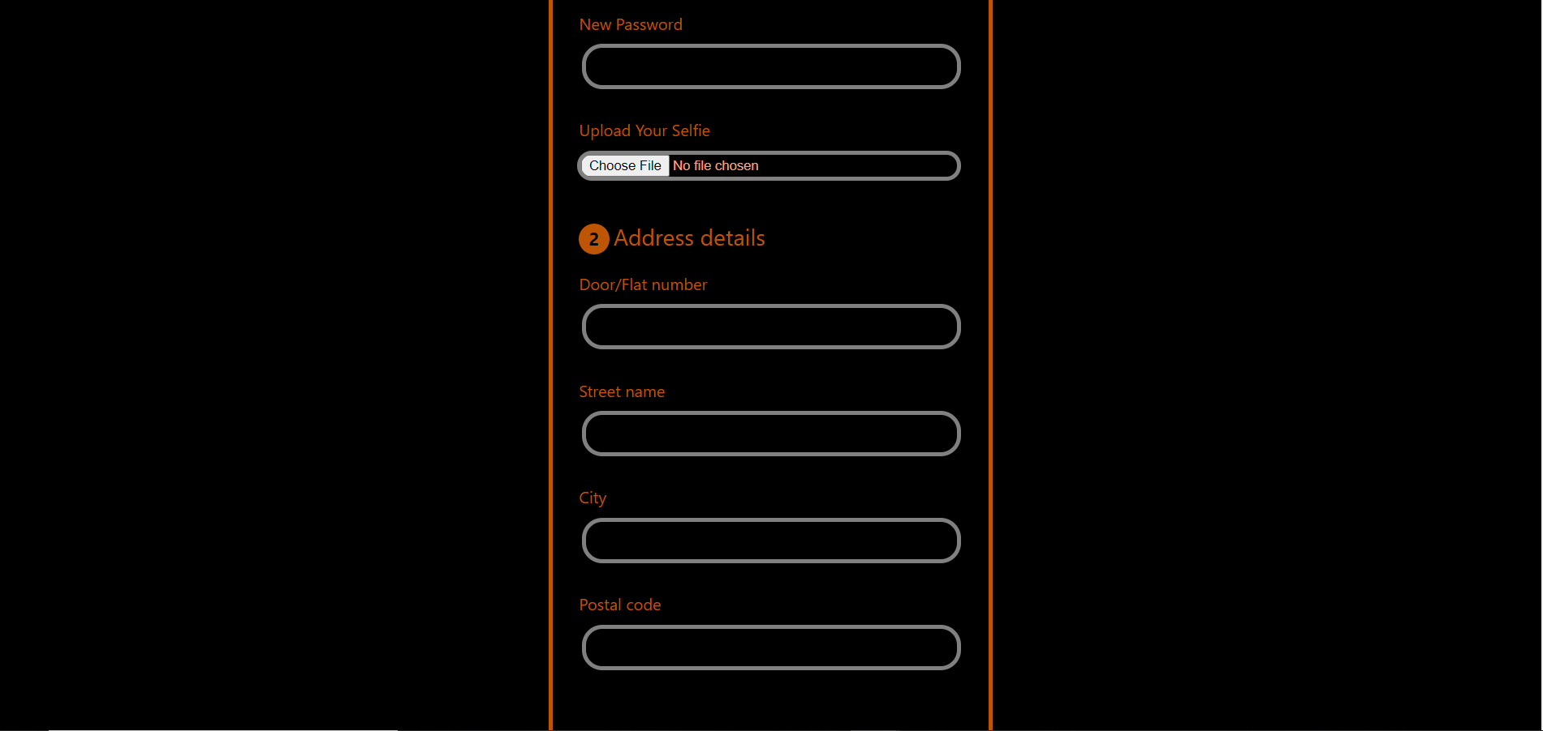

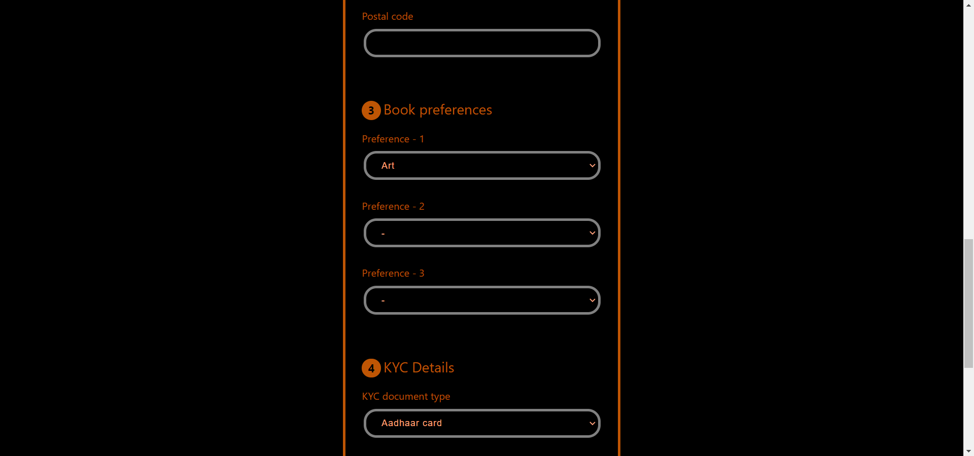

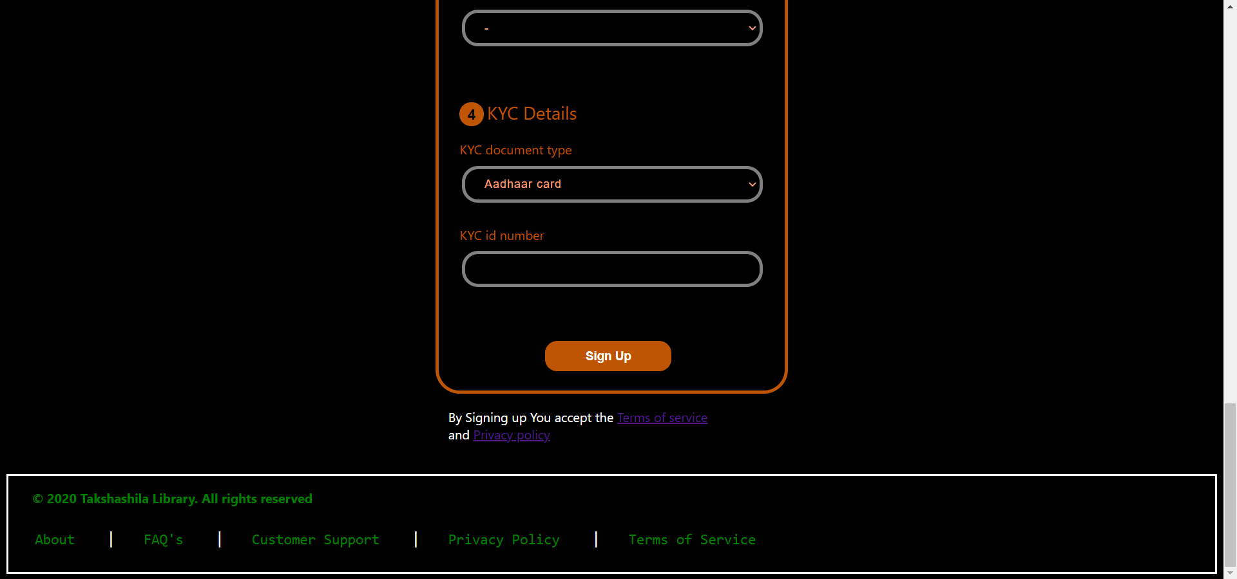

Login page:

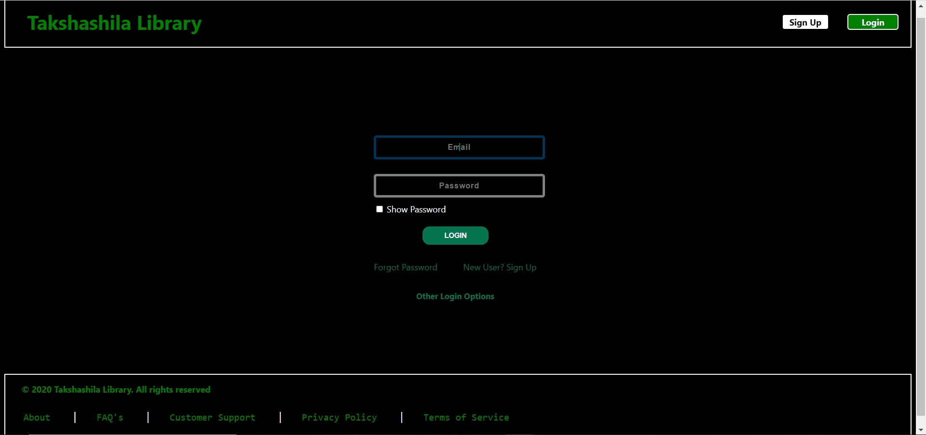

User home page:

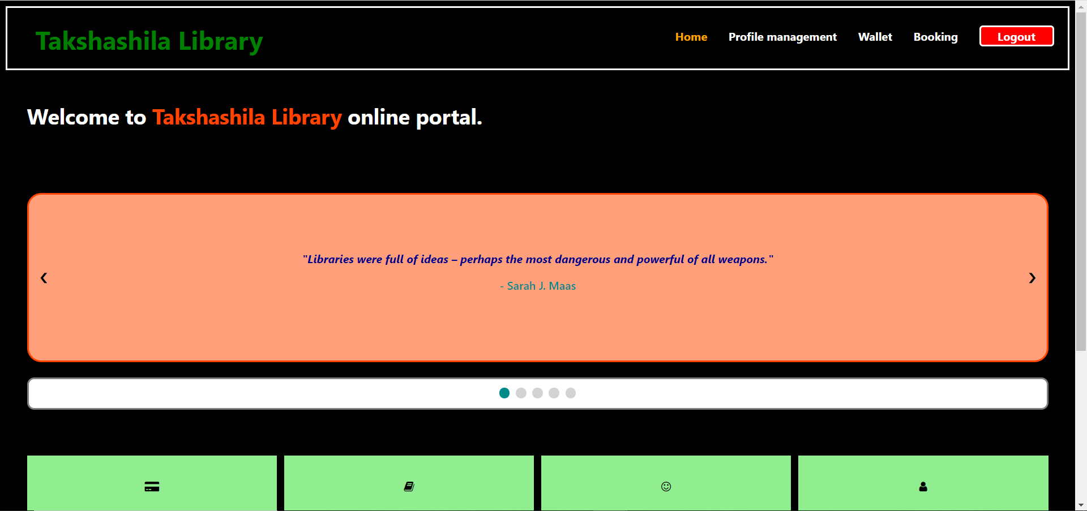

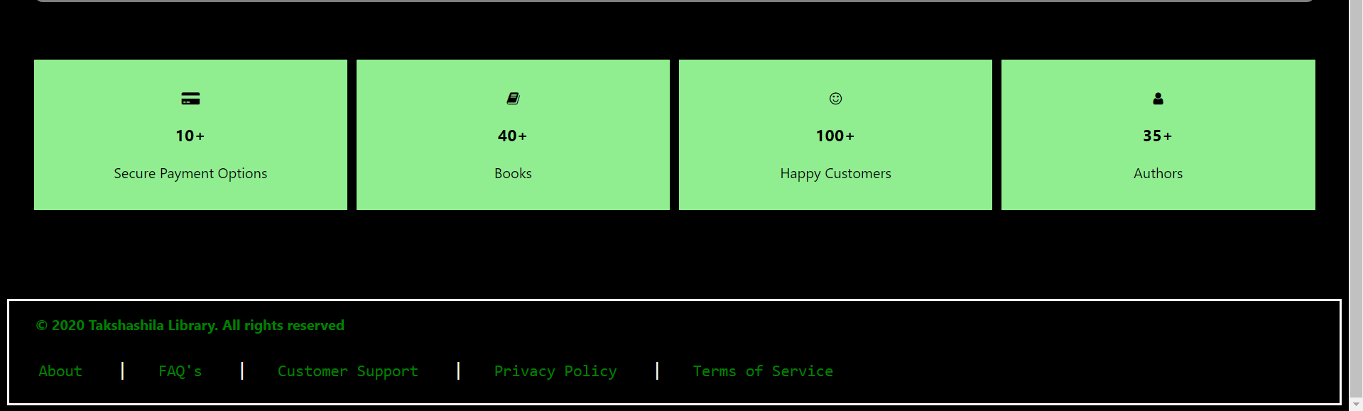

Profile Management:

-Show profile:

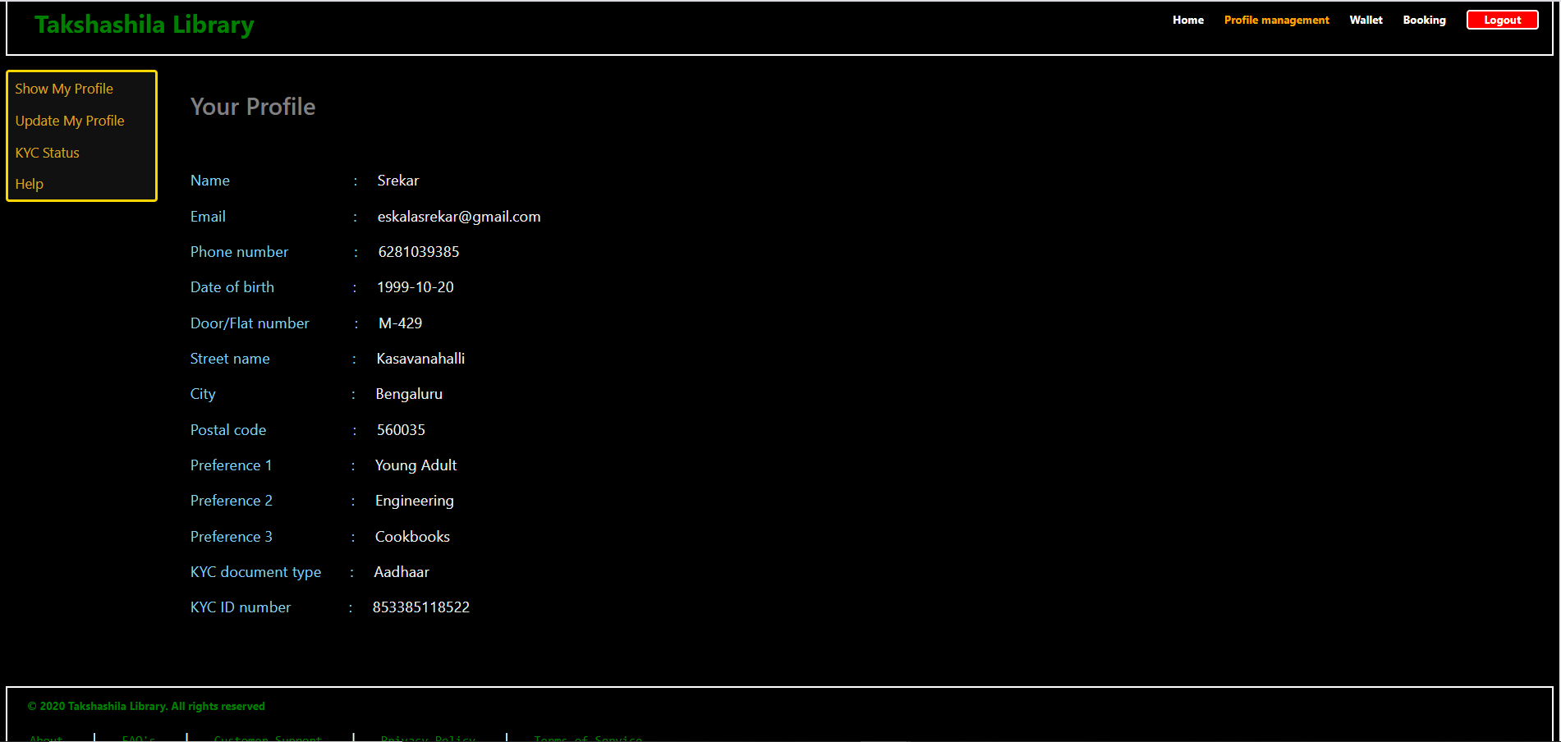

-Update Profile:

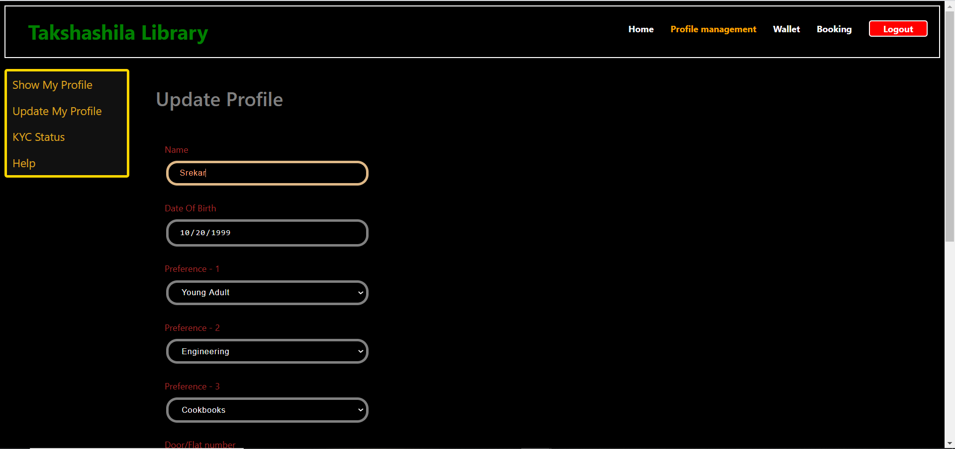

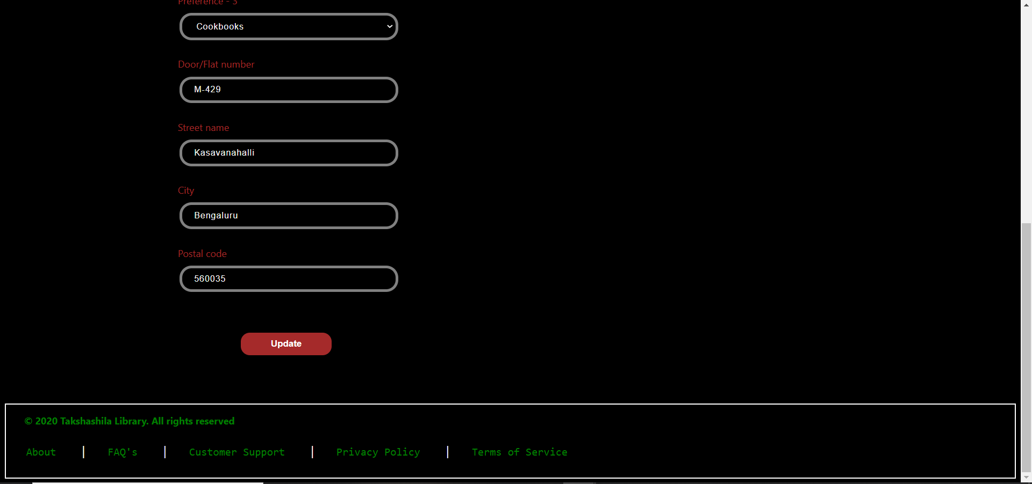

-Kyc Verification:

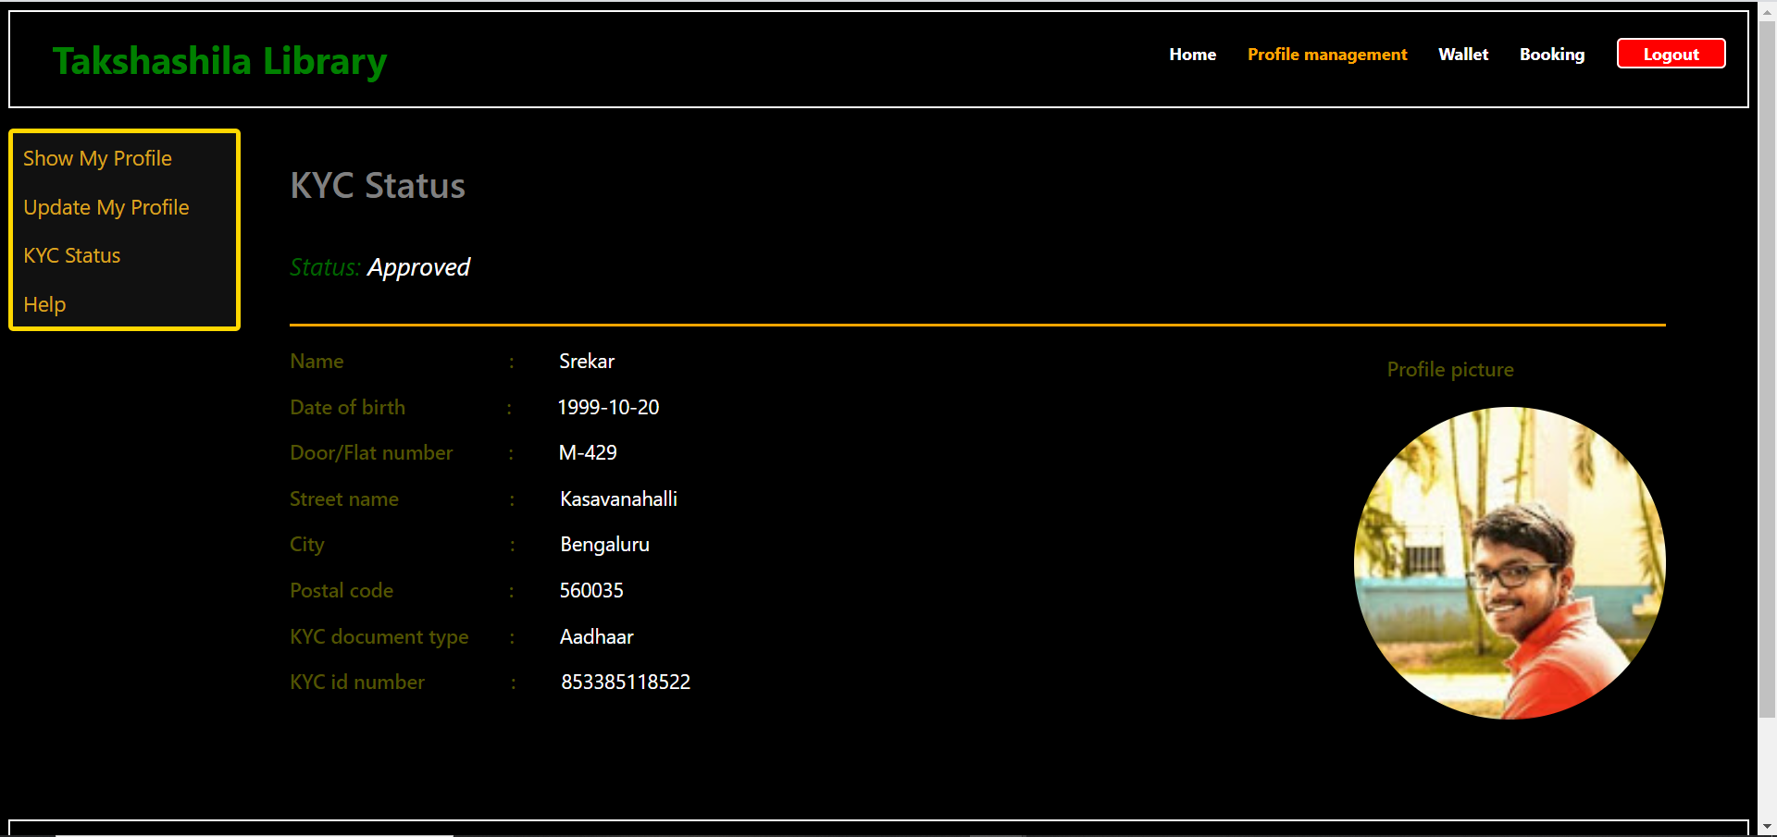

-Help:

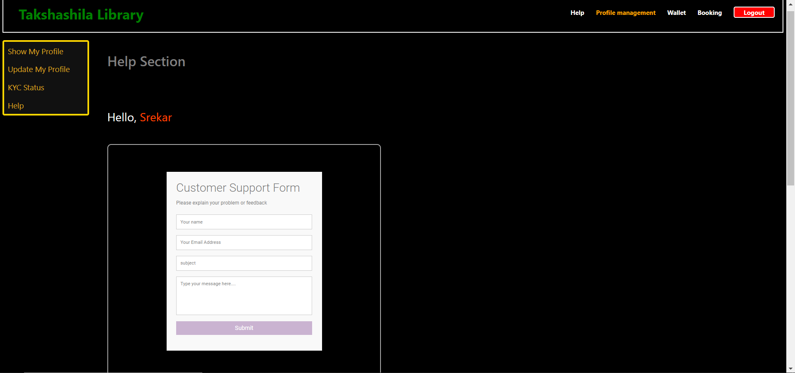

Wallet:

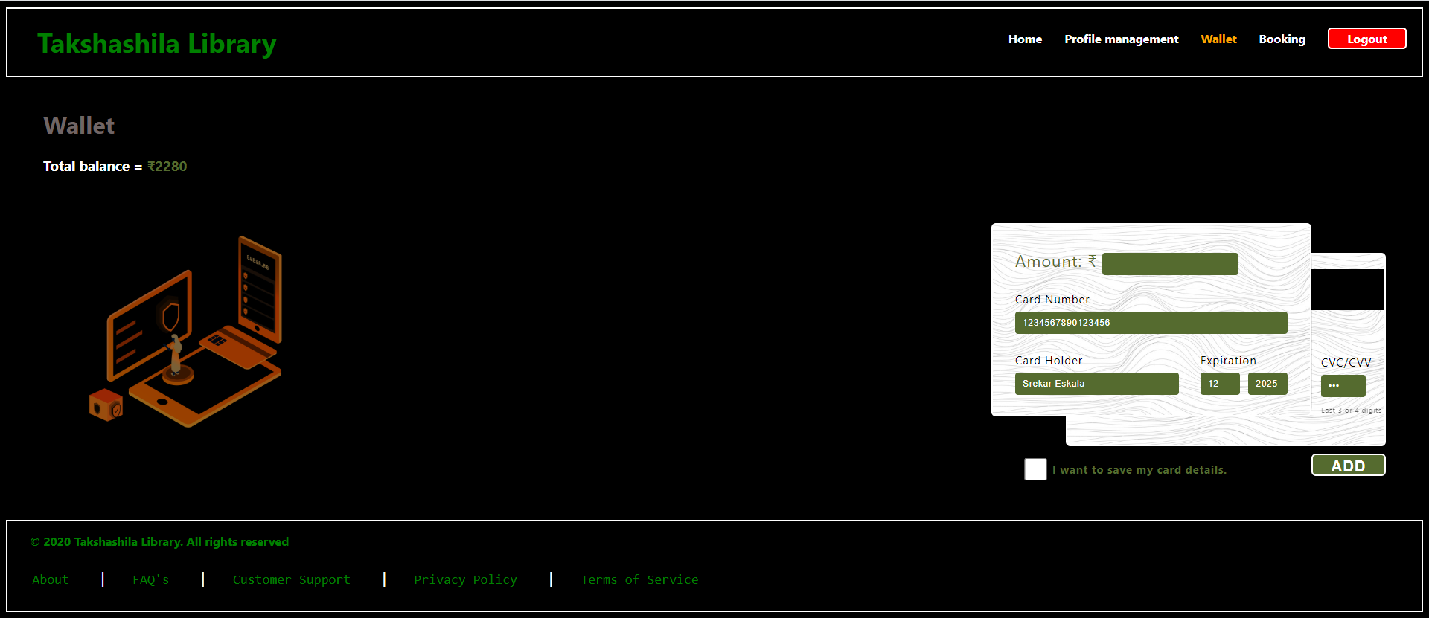

Booking:

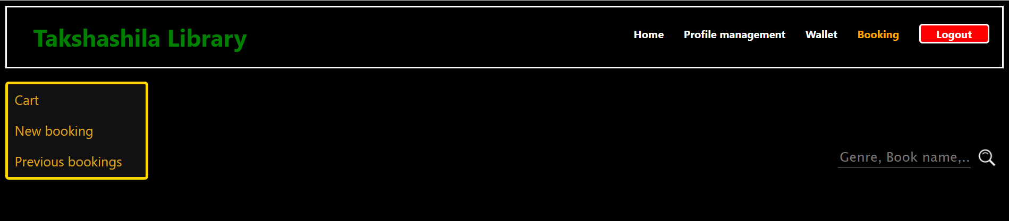

Page After logging out:

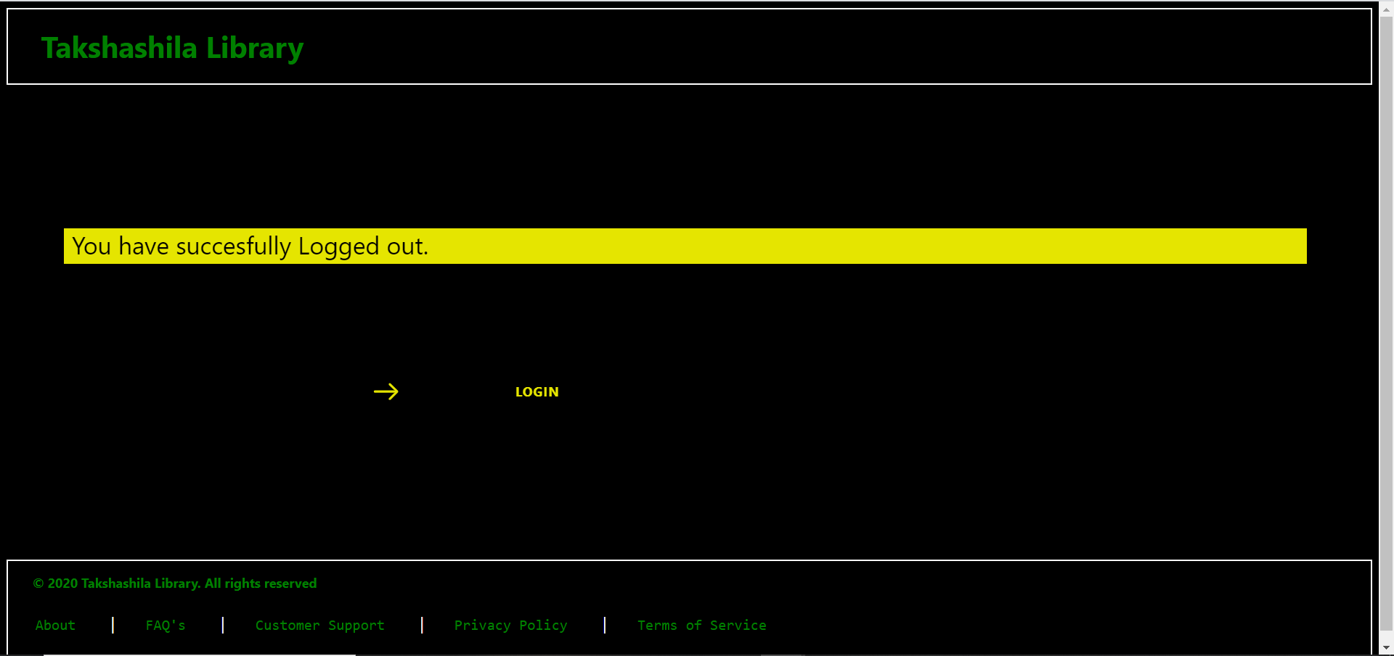

### 

### 

### **8.** **Sprint 2 Implementation**

Booking Module:

-New booking module:

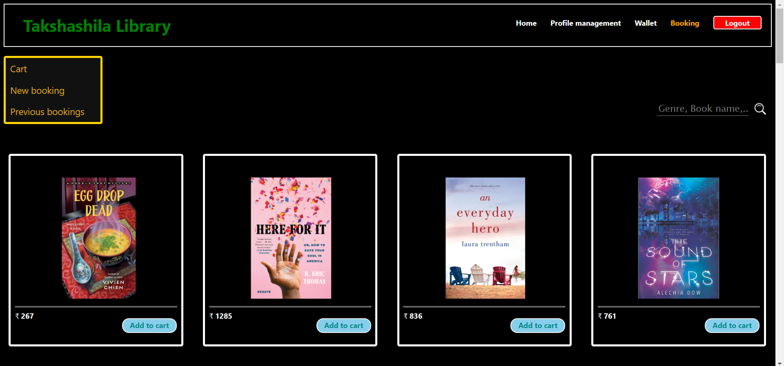

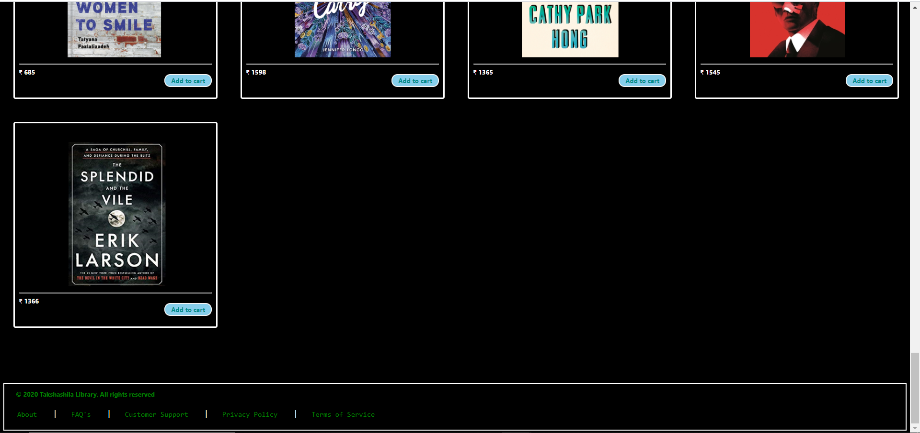

-Cart:

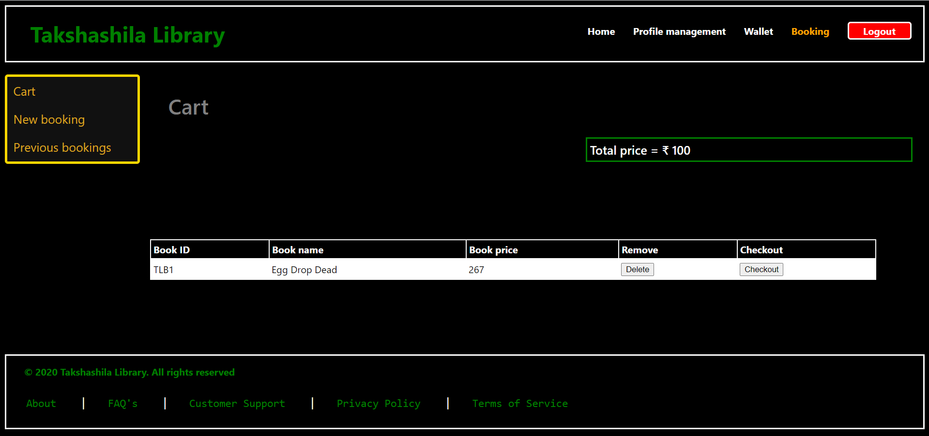

-Previous Booking:

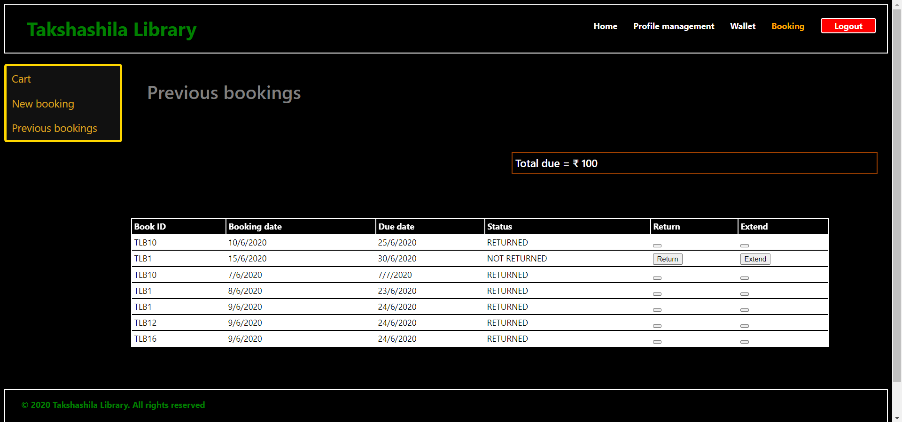

About:

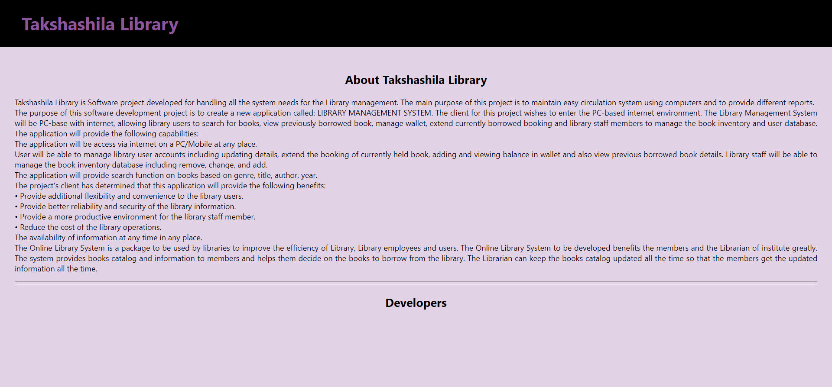

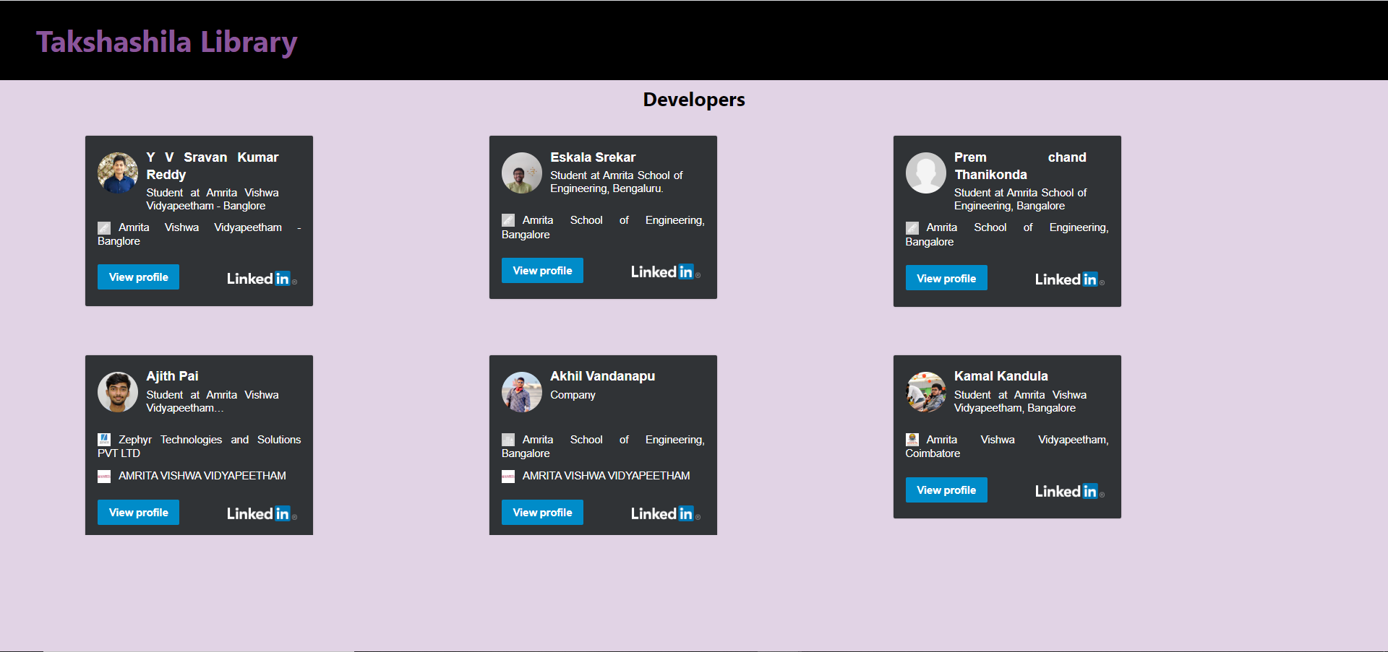

FAQ’s:

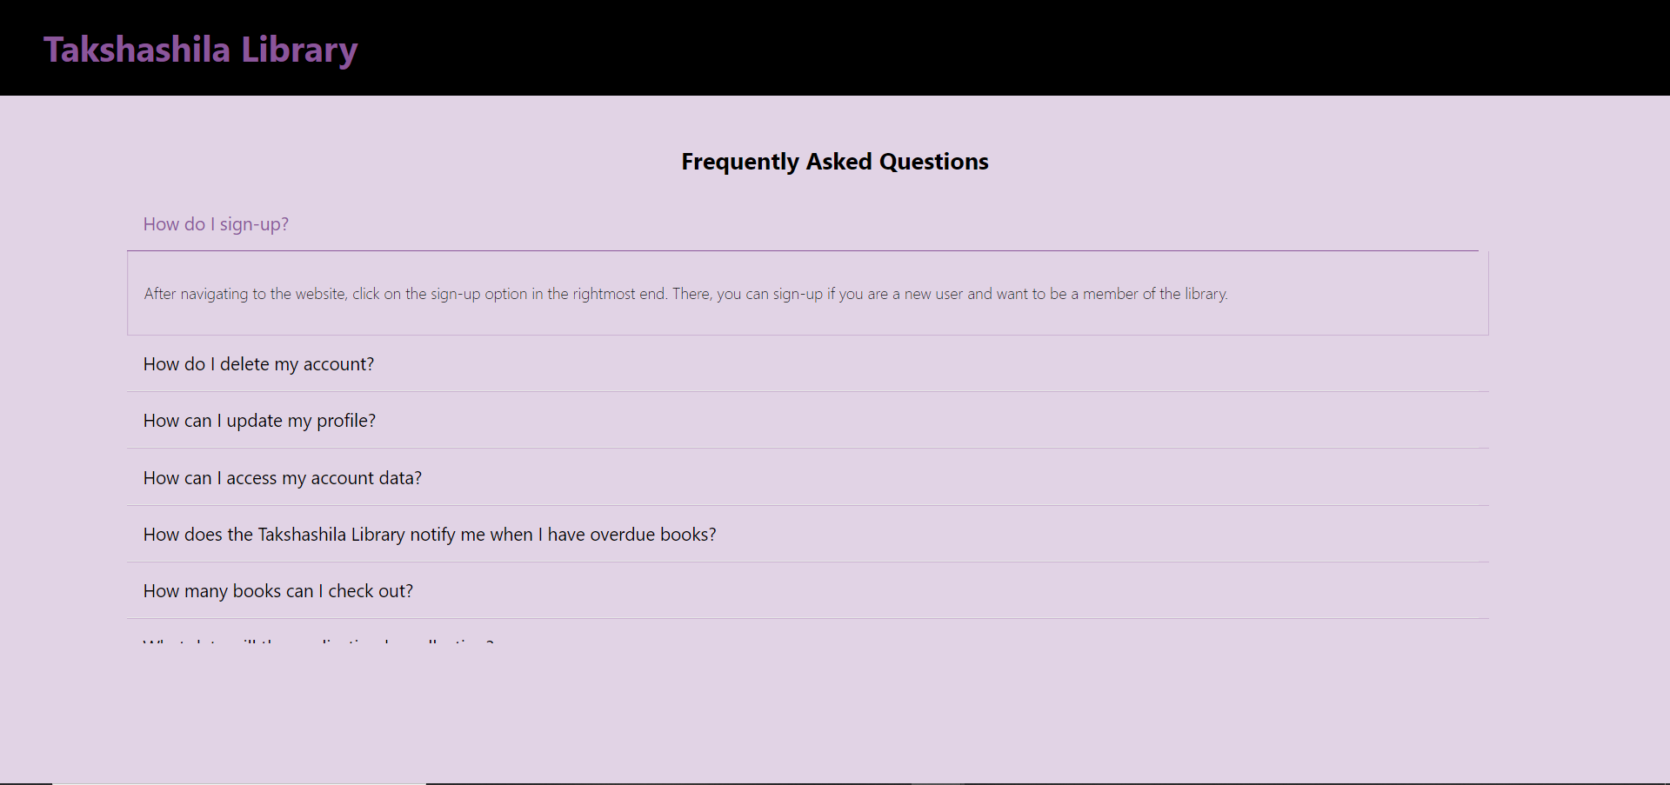

Customer Support:

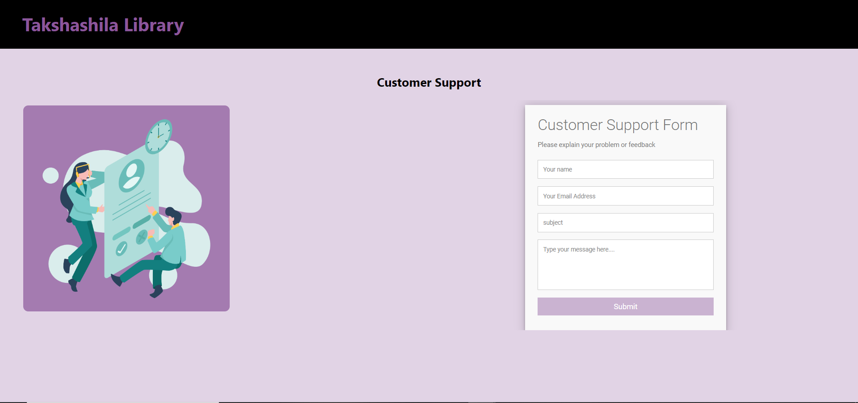

Privacy policy:

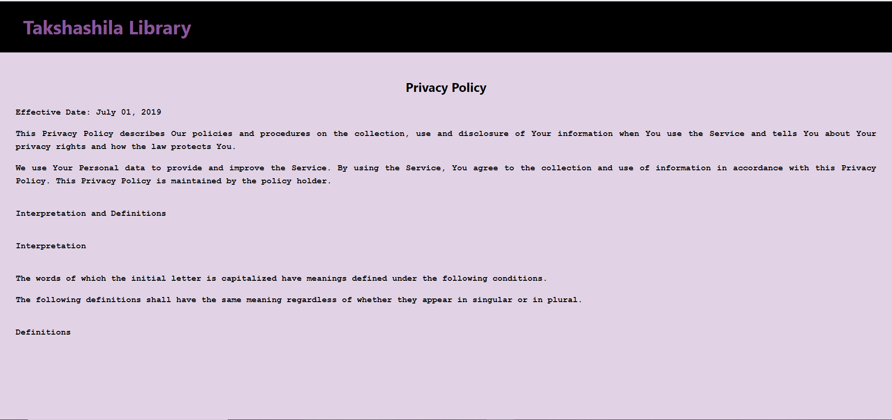

Terms of service:

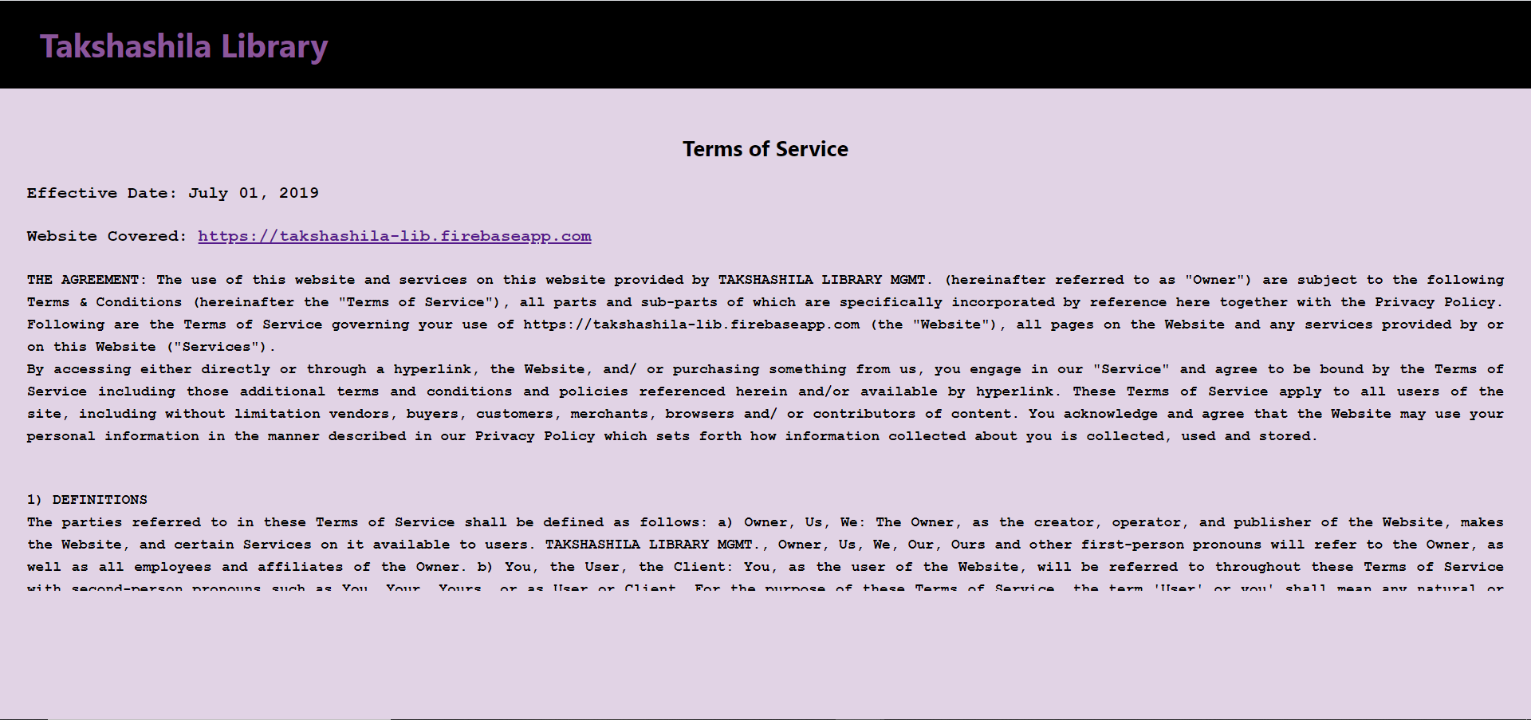

Admin Home Page:

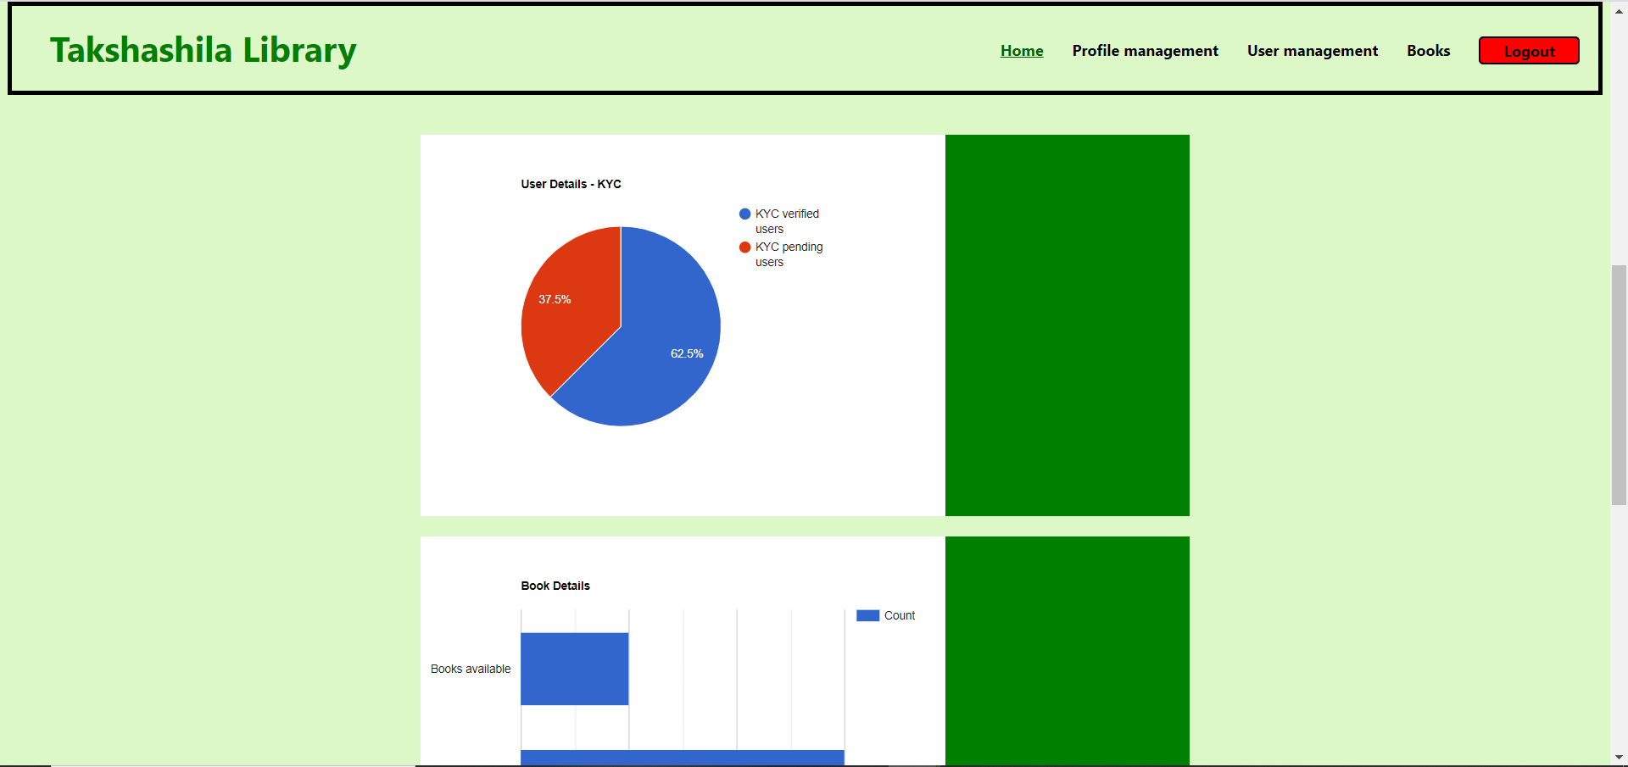

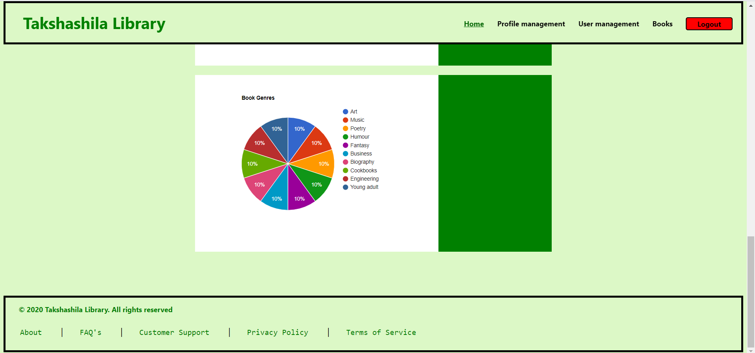

Profile Management Admin:

-View Profile

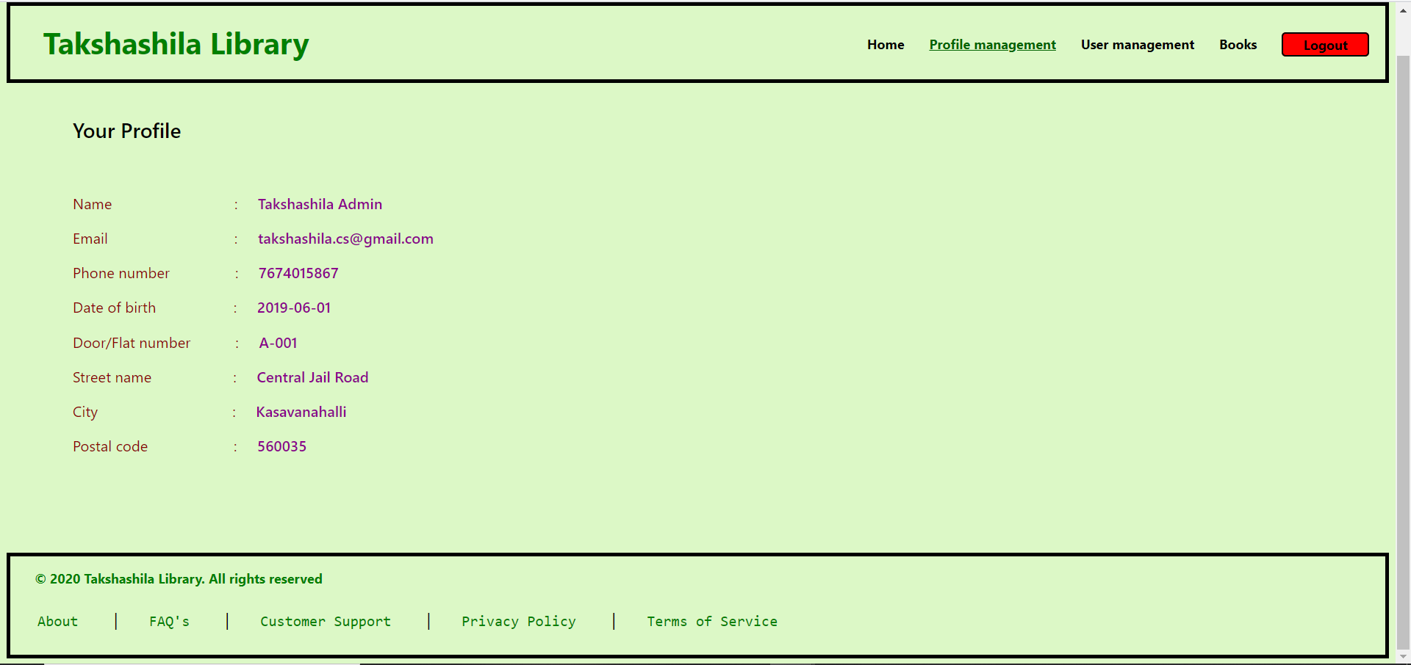

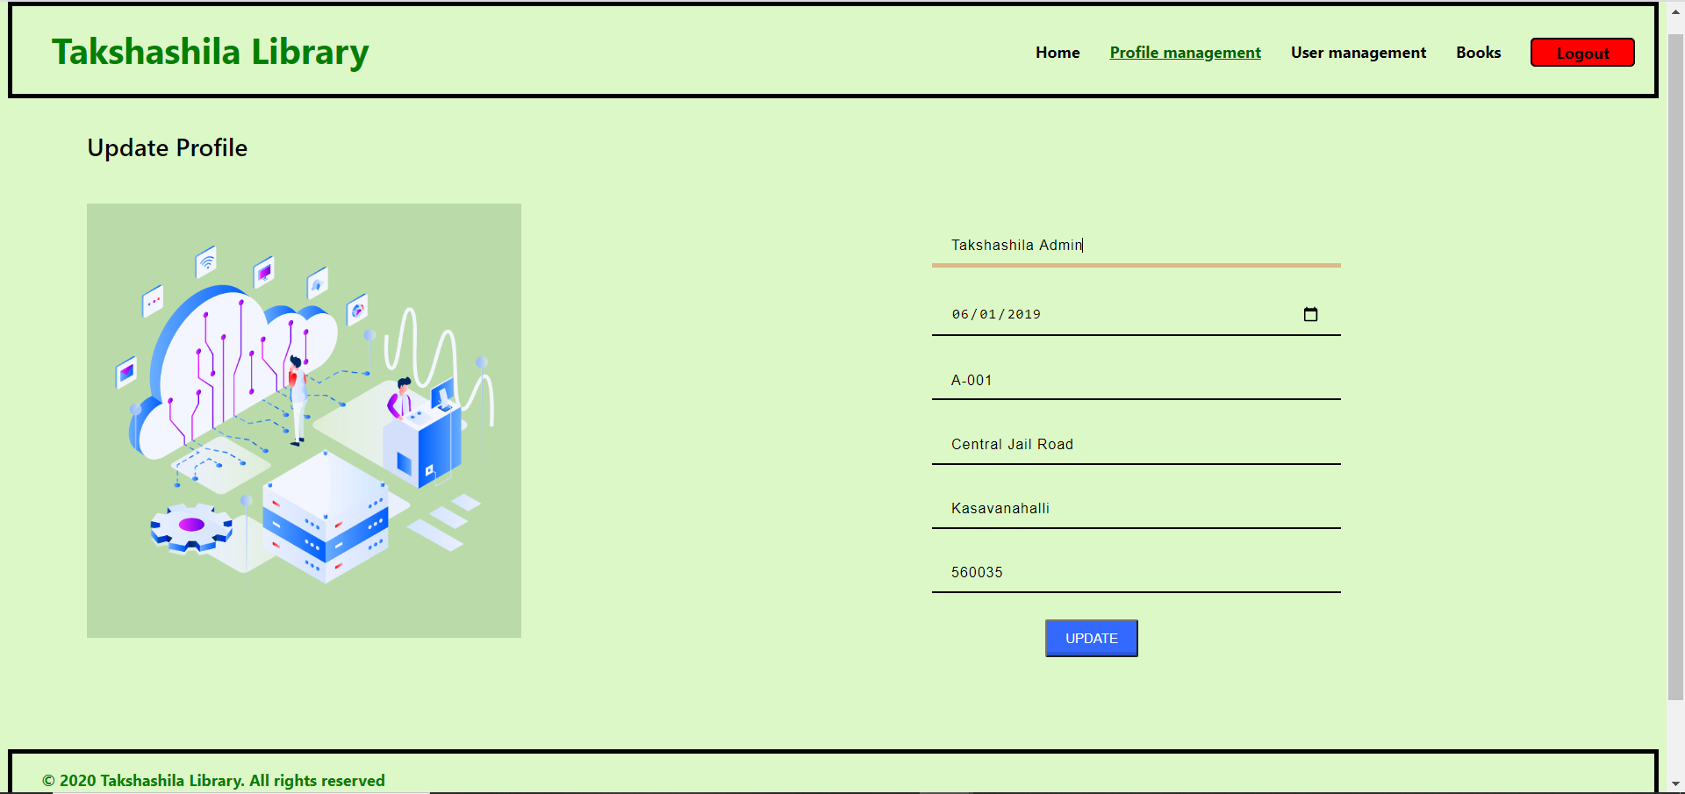

User Management:

-KYC verification:

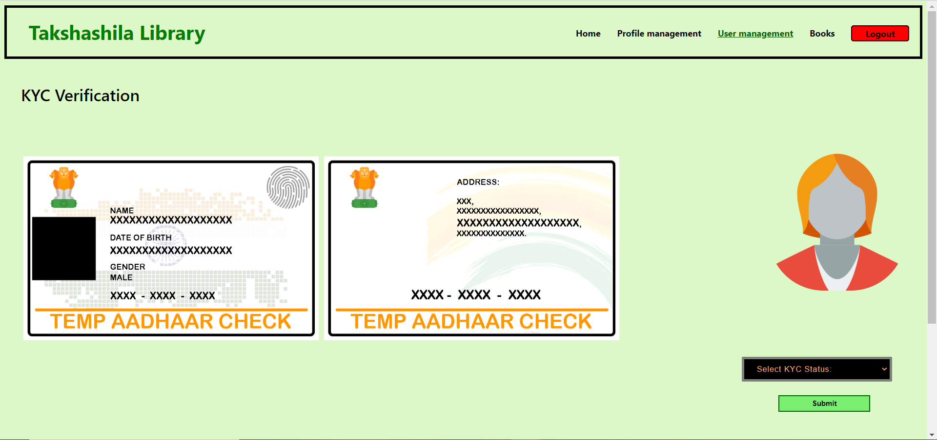

-Customer Queries:

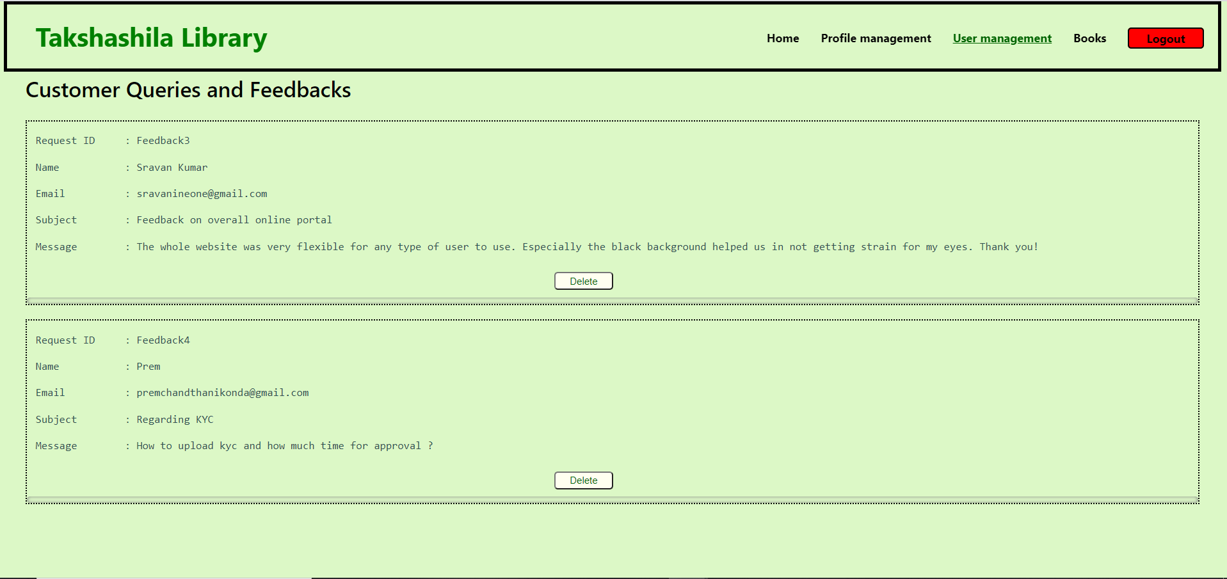

Customer Reviews:

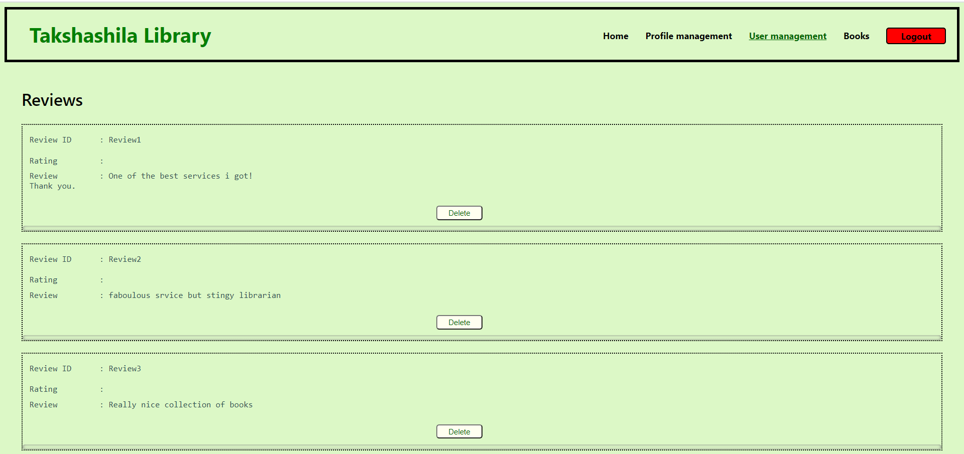

Books:

-Show books:

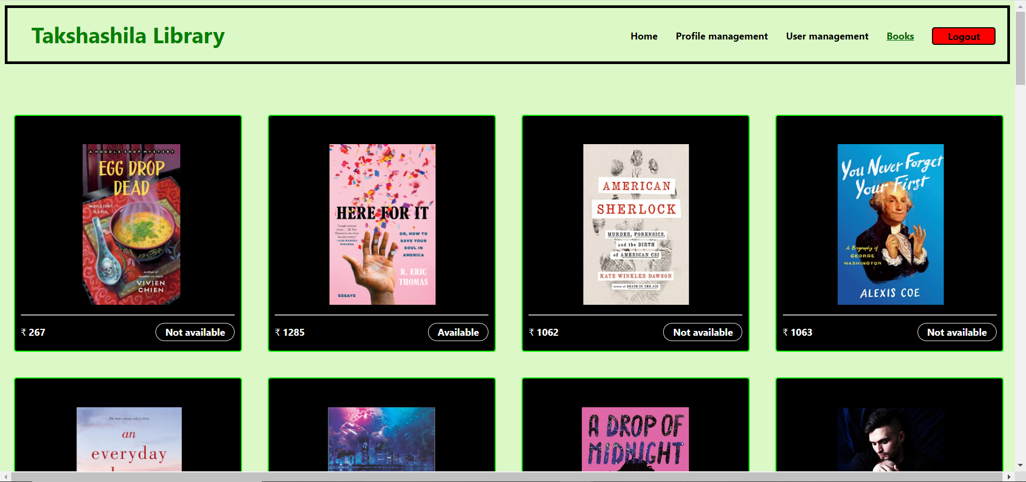

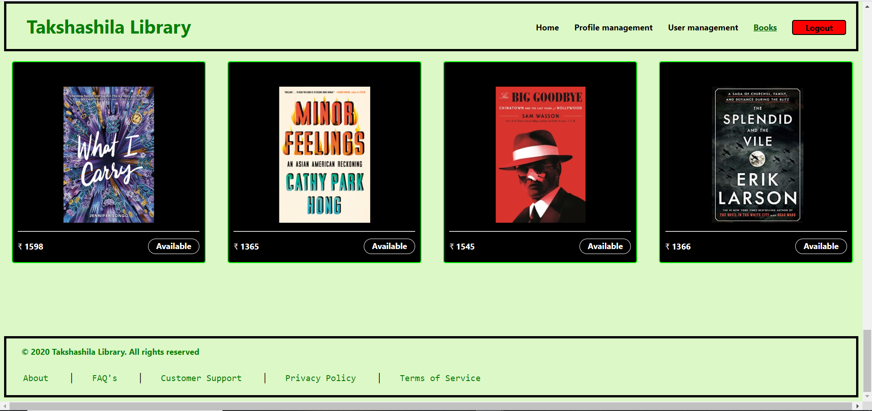

Manage Books:

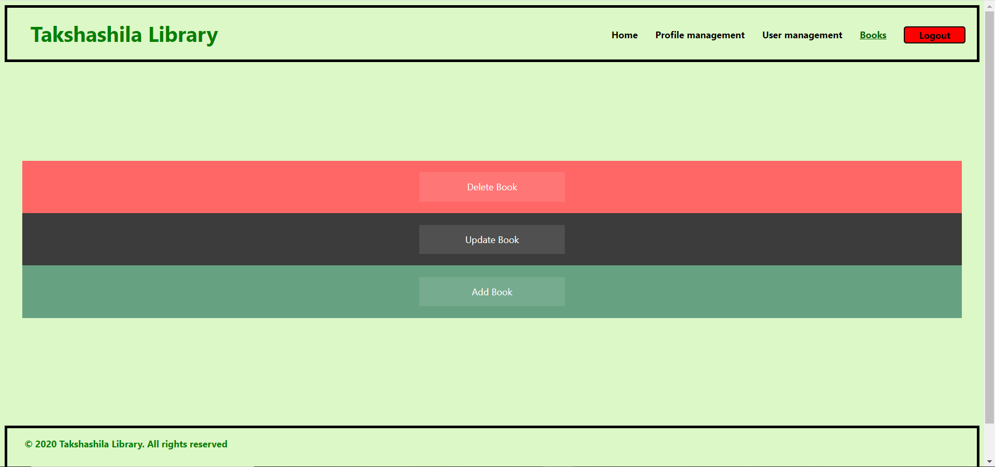

--Delete book:

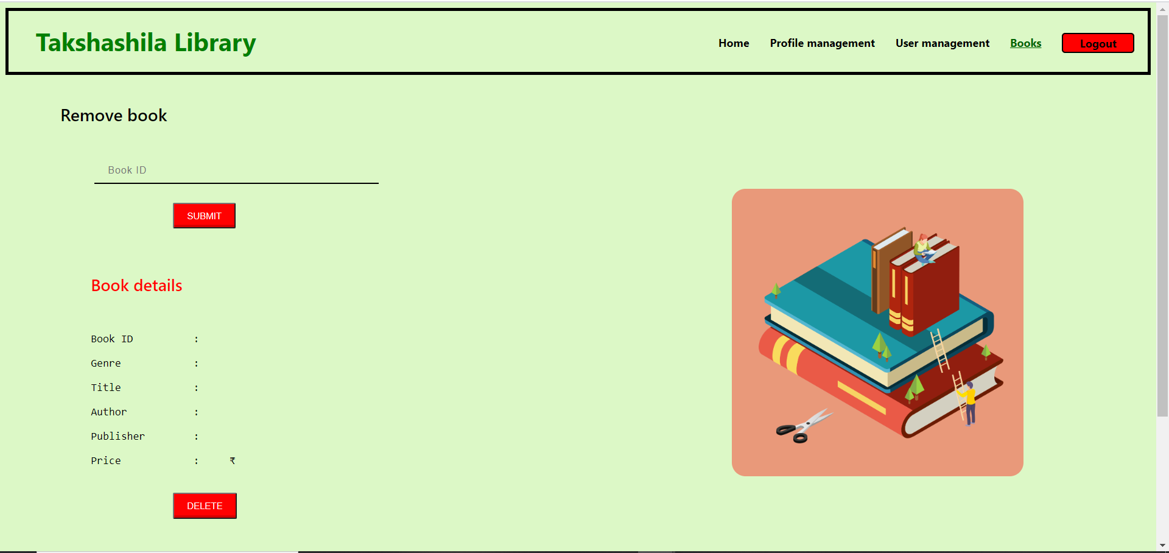

--Update book:

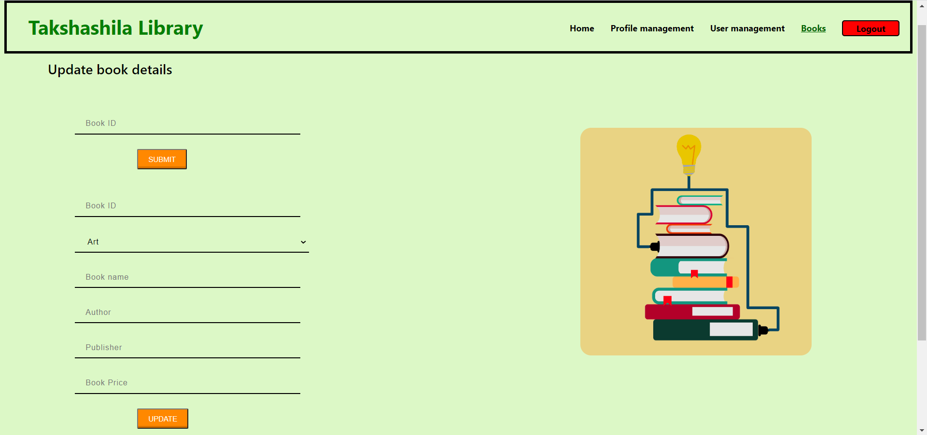

--Add Book:

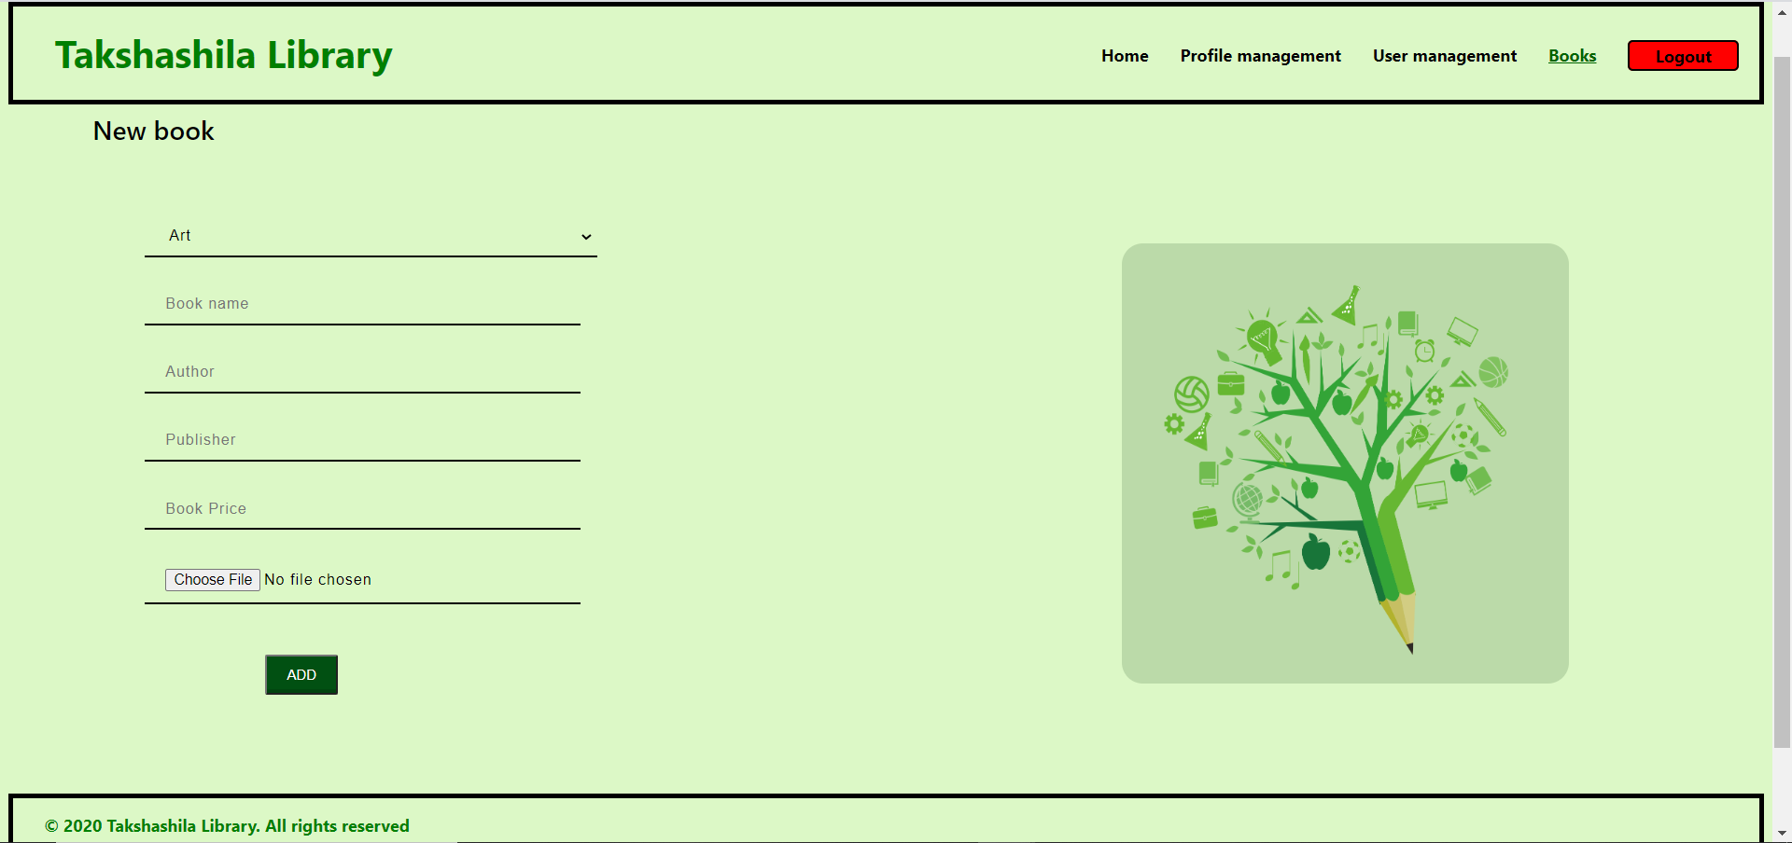

-Bookings:

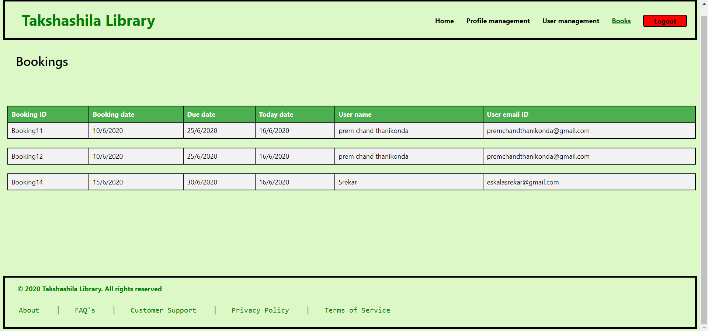

### 

### 

### **9.** **Sprint Review**

The sprint review was held on 28-02-2020 and attended by Ajith pai, Akhil Vandanapu, Kamal Kandula, Premchand Thanikonda, Y V Sravan Kumar Reddy, Eskala Srekar. Before approving or rejecting product backlog items as noted above, key decisions from the review were:

· More time is taken to load the details from the backend.

· While signing up the user is not able to recognize whether he was signed up or not

### **10.** **Sprint Retrospective**

The team held a sprint retrospective on 28-02-2020. It was attended by everyone. Key decisions were:

· Optimize the code so that the time taken for loading the data from back end is reduced / Add the buffer page in the front end for loading the details

· Added an alert box so that the user can understand the status of hi signing up